Arcimboldo

Fruit Face
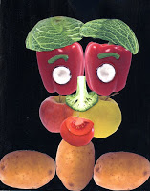
Giuseppe Arcimboldo was an Italian artist from the 1500s who spent years working as an official court painter. He developed a style of composing portraits from fruits, vegetables, etc., which was uniquely his own. There's a great book about him called "Fruit Face" which is what I used to introduce this lesson.
1. Find lots of large, colorful images of all kinds of fruits and vegetables from either magazines or stock photos online. I found that www.iStockPhoto.com has lots to choose from and are not too expensive.
2. Make color prints or color copies of all the images and distribute to the students, along with a scissors, glue stick and black construction paper. Show them how they can "build" a face by layering smaller, feature-like pieces on top of larger shapes. Careful cutting (removing all the background) will help make their face look nice and neat.
3. Lastly, the students will glue down all the shapes, starting with the background. Encourage lots of detail with clothes, accessories, etc.

Labels: 2nd grade, 3rd grade, 4th grade, 5th grade, artist Arcimboldo, collage

Bearden

Romare Bearden-Style Collage
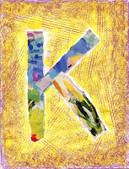
Many art historians consider Romare Bearden to be one of America’s most important and inventive artists.Bearden loved collage, combining painting, magazine clippings, old paper and fabric together like a jigsaw puzzle. This project gives a nod toBearden’s love of photos and texture, but also offers a kinder / 1st grade version of my “Collage Name Card”project.
SESSION ONE
1. Give each student a couple of colorful magazine pages, drawing paper, glue stick and pencil. The students are to center a large simple stick figure of their first name initial on the drawing paper, in pencil.
2. They then form their initial using approximately 1" wide magazine strips. Demonstrate how the magazine strips torn vertically, will stay be pretty even. The students are to trace their drawn initial with the glue stick, covering generously, and glue the magazine strips in place.
3. The students use a peeled crayon and a sheet of plastic canvas (sold at Jo-Ann Fabrics for about 50¢) to do a crayon rubbing with the side of the crayon, all around their collage letter.
SESSION TWO
1. The students use the Crayola Watercolor Mixing Set and water to paint just one solid color around their letter. When complete, they may take a paper towel to dab and speed up the drying process.
2. Finally, a small darker piece of peeled crayon is rubbed along the edges of the page.
Labels: 0 grade, 1st grade, artist Beardon, collage

Burch

Abstract Cat Face
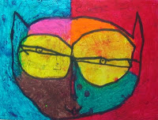
Let me just say, I adore this piece of art. It was made recently by a 2nd grader who was struggling with my suggestions of how to draw cat eyes. He said, and I quote, “But Mrs. Barbro, I like to draw my eyes THIS way.” That’s when I realized that sometimes you just have to step back and let children’s art evolve on it’s own terms.
If you would like the full instructions to this project, go to the "Laurel Burch Cat Heads” post.
Labels: 2nd grade, 3rd grade, 4th grade, 5th grade, artist Laurel Burch, oil pastel
5 comments:

FEB 17, 2011

Laurel Burch Cat Heads
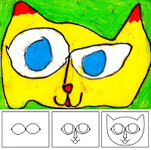
This cat project was inspired by a talented artist named Laurel Burch, who sadly passed away recently. She had a wonderful style of drawing abstract cats with large eyes that met in the middle.
1. Ask students to make three dots (in pencil) across the center of a paper as per the diagram. The 3 dots are connected to make the eyes. A triangle nose is added, nose lines and mouth. Lastly, the outside of the head is drawn around the head.
2. Students use a black Sharpie marker to trace all their lines.
3. Distribute oil pastels and encourage the students to use unusual colors to fill in their cat and background.
Labels: 1st grade, 2nd grade, artist Laurel Burch, drawing, oil pastel
4 comments:

MAY 28, 2010

3D Laurel Burch Cat
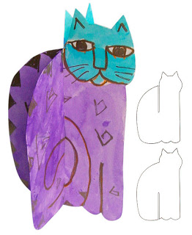You can use this idea to turn any silhouette into a 3-dimensional shape. Just make sure you use a thick paper so your design will stand up nice and straight.
1. I love using Laurel Burch's cats as inspiration for projects, her style is so fun to imitate. I made a two cardboard templates of a silhouette (see picture) and had the students trace each onto the heaviest watercolor paper I could find.
2. Each student is to cut out their two cats, including the narrow slits. They need to be about 1/32" wide to accommodate the thick paper. Test sliding the cats together to make sure the slits are working.
3. The students may then draw in pencil their cat design, which they need to repeat on both sides of the two paper cats. When the design is done, they paint in the shapes and designs on their cat with liquid watercolor.
4. After the paint is dry, I gave each student a gold poster paint marker and had then trace all the pencil lines. When the marker is dry, slide the cats back together and enjoy seeing your cat from all directions!
Labels: 4th grade, 5th grade, artist Laurel Burch, paint, three dimensional
10 comments:

APR 22, 2010

How to Draw a Laurel Burch Cat
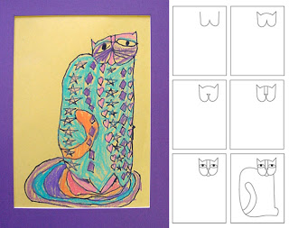This project was inspired by a talented artist named Laurel Burch, who has now sadly passed away. She developed an abstract style of painting cats that is really fun to imitate.
1. For young students, do a step-by-step drawing session as the diagram shows.
2. After the cat is drawn in pencil, have the students trace the lines with a marker, and add fun patterns to their cat body if they wish.
3. A final coloring with construction paper crayons will complete their picture.
Labels: abstract, artist Laurel Burch, construction crayons

Chagall

Chagall Inspired Watercolor
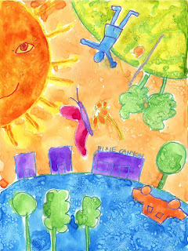Marc Chagall, one of the most successful artists of the 20th century, created many paintings that were a dreamlike, surreal tribute to his native village of Vitebsk. In order to have students connect with the idea of Surrealism, I’m going to have them create a painting that has some elements upside down, and some out of scale with each other.
1. I’m going to do a follow-along drawing with the students just to get them started with the idea of making a mixed up drawing. On a 11" x 15" watercolor paper, I will ask them to make a curved horizon line near the bottom third of the paper. A few buildings will be added on top (in my case, the entry to our school), along with some trees.
2. The top left or right is a good space for a large sun. It should be only half on the page, with some kind of face included.
3. The students then turn the paper upside down, and draw another large element in the space that is left over. My sample has a figure playing tether ball (a new addition to our school). Small figures, animals or cars may be fit in where possible.
4. When the paper is filled, all the lines are traced heavily with crayons of different colors.
5. The shapes are all painted in with watercolor. While the paint is still wet, some areas will be sprinkled with salt to create texture. When the painting is dry, the salt is brushed away.
Labels: 0 grade, 1st grade, 2nd grade, 3rd grade, 4th grade, 5th grade, artist Chagall, watercolor

Close

Chuck Close Self Portrait
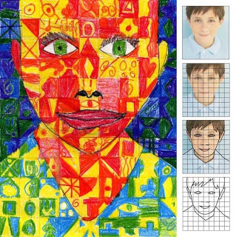Chuck Close is an American painter and photographer who first achieved fame as a photorealist. This project, which imitates his style, takes a bit of planning, but the results can be spectacular.
1. Take digital photos of the students. With my computer graphics software, I cropped the faces in Photoshop and printed them out (black & white) to fill an 8" x 10" box. Cut out all the photos.
2. Create and print an 8" x 10" grid sheet filled with a 1" lines for each student. Cut out all the grids. Cut sheets of carbon paper that are 8" x 10" square. Stack the photo on the carbon on the grid paper. Tape together. The students are to trace all the edges of their faces on the photo, which will transfer to the grid.
3. Once the face edge lines are on the grid paper, instruct the students to pick a pair of pencil crayons each for the face, neck, background and hair. Each square in these areas is to be filled with any kind of shapes and patterns, but only with the chosen pair of colors. Repeat until all the areas are filled. The eyes look best just colored normally without any patterns.
Labels: 5th grade, artist Chuck Close, pencil crayon, portrait

Delaunay

Delaunay Marker Drawing
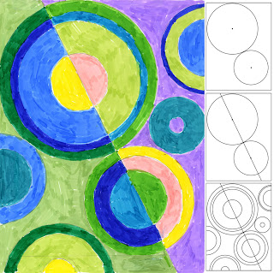Sonia Delaunaywas a ground-breaking female artist who made some wonderful abstract paintings known for their rhythm and color. My goal was to have the students learn that if they used repeating shapes and colors in their art, they could create a very rhythmic picture too.
1. I found a vital piece of equipment at Michael’s, a circle scissor that helped me make dozens of circles from 1" to 6" wide out of card stock paper. I passed out both the inside and the outside circle shapes to trace, along with a ruler. The goal was to have a picture filled with shapes that are limited to full circles and half circles, but no other kind of splices. The best way to control this is to ask the students to trace one large circle and one smaller one in any placement on their paper. A center dot is drawn in the middle of each.
2. With a ruler, the student is to draw a line through the center dots.
3. More circles can be traced and added inside and out, but always centering them to the best of the student’s ability.
4. We used good old Sharpie markers for coloring, and I had the good fortune of having some coated white paper on hand. It really made the markers glide on, but I bet that regular paper would look just as nice. Remind the students that they are to have repeating colors. Each marker should be used in at least 3 different places. I personally love how these drawings came out – wish I could make giant posters out of them!
CA Visual Art Standard: Creative Expression, Grade Four
2.6 Create an original work of art emphasizing rhythm and movement....

Labels: 4th grade, 5th grade, artist Delaunay, CA Art Standard, markers

DeMuth

Abstract Numbers
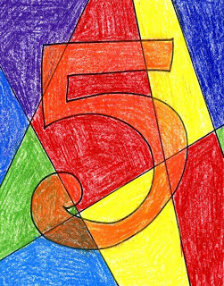Charles DeMuth was an American artist who lived in the early 1900's, and became famous for his abstract paintings that used lines to fragment and divide his canvas.
1. DeMuth's "Figure 5 in Gold" is a wonderful abstract painting to show children as they can easily see the firetruck elements in it. Start by having students draw their own large block number on a piece of paper. I like to give the kids a choice of doing the 5 or another number. Single digits are best though.
2. Using a ruler, they can draw about 5-6 lines from edge to edge to dissect the paper into many sections. Encourage them to spread the lines out, and then trace all with a black marker.
3. I used Art Stix to color this piece as they are bright and not too messy, but you could use crayon or oil pastels too. Have the students choose one color for the inside of their number. In my example, I colored the inside of my 5 with orange first. When that is done, they can color in each segment with different colors, overlapping to create a new color when necessary.

Labels: 1st grade, 2nd grade, 3rd grade, abstract, artist DeMuth

Dubuffet

Dubuffet Cow Drawing
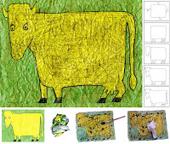
Jean Dubuffet painted “The Cow with a Subtile Nose” in 1954, and I’ve always wanted to see how close I could get to the look with a good old crayon and watercolor resist. I do recommend that you have your students use a light color for the cow, and a dark watercolor to get the most contrast for their wrinkles.
1. To draw the cow, first start with a large square with rounded corners. Older students may be able to follow the placement on the paper.
2. The feet and udder are added below.
3. A neck is extended from the body and a long head is added. Ears are drawn on the side.
4. Eyes and nose are added to the face.
5. The tail is drawn on the back. Lastly parts of the rectangle are erased so it looks more like a cow body.
6. The drawing is traced with a black Sharpie, and colored very heavily with crayon.
7. The paper is crumpled up, opened up and smoothed. Repeat 3 times.
8. Dark watercolor paint is generously spread over the entire painting.
9. Rub a paper towel over the entire picture to smooth. Moooove to a drying rack and enjoy!
Labels: 2nd grade, 3rd grade, 4th grade, 5th grade, artist Dubuffet
2 comments:

JUL 20, 2010

Dubuffet Self Portrait
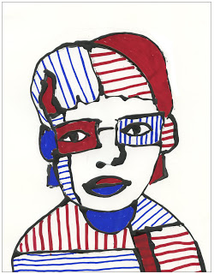Jean Dubuffet (1901-1985) was a French painter and sculptor who preferred what he called “raw art”. This came from non-professionals who worked in very primitive ways. He routinely added sand, tar and straw to his paintings to give them an unusual texture. His playful style is fun to imitate and can encourage some very creative portraiture.
1. Start by sketching a large simple drawing of yourself on a sturdy piece of paper. No tiny details, just outline of hair, eyes, nose, shoulders, etc. Draw a few horizontal and vertical lines on the body, hair and face to divide up the areas into smaller parts. Keep in mind that the lines will be traced with a glue bottle so tiny details are not necessary.
2. Make a mixture of 50/50 white glue and black acrylic paint in a squirt bottle, and shake to blend. Trace over all the pencil lines with the black glue. Remember that Dubuffet liked rough looking images so wiggly black lines that are sometimes thin and sometimes thick are what you are trying for. Let the glue dry overnight.
3. A lot of Dubuffet’s paintings were done with just red, white and black colors, so I limited myself to a red and black Sharpie, and randomly added stripes in some areas, and solid colors in others. Some spaces may also just be left white.
Labels: 3rd grade, 4th grade, 5th grade, abstract, artist Dubuffet

Carle

How to Draw a Seahorse
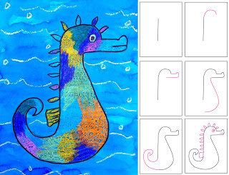
If your students are ever learning about amazing animals, then a book from Eric Carle titled “Mr. Seahorse” is a great lead-in to this project.
1. Students draw a seahorse in pencil as shown in the diagram above.
2. They trace their drawing with a black permanent marker.
3. The seahorse is colored in with crayons, the more colors the better. White crayons may be used to add wave lines in the background.
4. Blue watercolor paint is brushed over the entire paper. I love the Turquoise Blue Liquid watercolor paint from Dick Blick, but I'm sure lots of other shades of blue will look great too.
Labels: 0 grade, 1st grade, 2nd grade, 3rd grade, 4th grade, 5th grade, artist Eric Carle, watercolor

Dine

Jim Dine Shiny Valentine
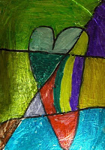
Jim Dine, an American Pop artist, used a lot of common images in his art, but is best known for his heart paintings. His creative style is one students can really appreciate as he liked to experiment with colors.
1. A sturdy backing is needed for the aluminum foil drawing. Old matte board is good, but any smooth chip board would do. Cut the board into 5" x 7" rectangles.
2. Distribute a board, glue stick and many colored Sharpie markers. Tear or cut a rectangle of aluminum foil about 7" x 9" for each student. The students cover one side of the board in glue, and then center and wrap the foil around it with the shiniest side out.
3. Students draw one large heart in the middle of the card, and then 3 or 4 straight lines from edge to edge that dissect the card. All the sections that are made from this are to be colored in with different Sharpie markers.
Labels: 1st grade, 2nd grade, artist Jim Dine, valentine's day
10 comments:

JUN 1, 2006

Ode to Jim Dine Diagram
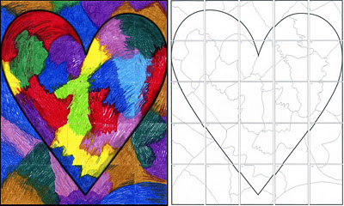
Labels: artist Jim Dine

Esher

M.C. Escher Tessellations
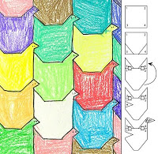A tessellation is created when a shape is repeated over and over again covering a plane without any gaps or overlaps. I learned the hard way how easily triangles can get flopped and rotated, so I came up with a numbering process that eliminates the problem.
1. Give each student a 3" (or larger) square of heavy card stock paper, scissors, tape, and drawing paper.
2. Make a diagram on a board that follows the steps illustrated.
a. Number the corners as shown.
b. Cut the bottom two corners off and move up to the top. With edges "kissing" and not overlapping, tape in place. The numbers are to stay right reading.
c. The students draw a triangle on the back side, label "H" for head, and move to the right top and tape in place to make a bird shape.
3. Using the bird as a tracing template, they align it with the side of a drawing paper, and trace one stacking column. If they move the bird to the right and interlock the head shapes, they can make another column that interlocks with the first. Continue tracing columns until paper is filled.
4. Pencil lines are traced with a marker and the shapes are colored in. This artwork uses crayon, but painting would look very nice too.
Labels: 4th grade, 5th grade, artist M.C. Escher, construction crayons
4 comments:

JUL 17, 2011

Fish Tessellation
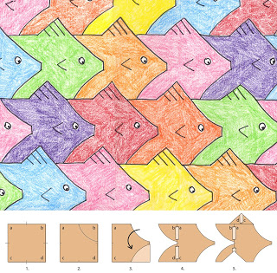A tessellation is a collection of shapes that fill a paper with no overlaps and no gaps. I like the combination of math and artistic skills they require, and am happy to say that this design is my very own.
1. Start with a card stock square, at least 3" wide. I recommend labeling the four corners as shown in diagram 1. Measure and mark the middle of each side of the square.
2. On the top right corner, draw and cut out a curve, leaving a little flat space that I like to call the “nose”.
3. The top curve piece is flopped and traced to make a symmetrical version below. Cut out the shape.
4. Both curved shapes are aligned and slide to the back of the square as shown. Tape in place. It is VERY important that the numbers read as shown as flopped and rotated shapes will not fit together when complete.
5. Cut one equilateral triangle from the bottom of the shape. It is slid to the top, aligned with the front of the fish and taped in place.
6. Place your fish on at least a 9" x 12" drawing paper, and trace. It’s best to make one row going across the paper first, and then add rows on top, always interlocking the shapes when tracing. Lastly, trace the lines in black marker and color with crayon. See artwork by M.C. Escher to get inspired for more complex tessellations.

Labels: 4th grade, 5th grade, artist M.C. Escher, construction crayons

Haiti Artists

Haiti Market Day Mural
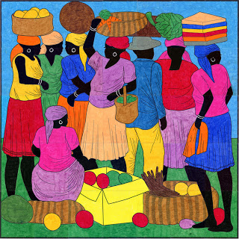
I created this mural to celebrate the colorful work of Haitian artist Berny Mathias, and to continue to raise funds for Project HOPE Art in its commitment to bring creativity and a few basic needs to Haitian orphans.

This fundraising mural contains 12-, 24- and 35-page versions (preview HERE) of Berny Mathias’ “Market Day” painting. Instructions and color guide are included. To purchase this fundraiser at the special price of $10, click the “Add to Cart” button to make your payment via Paypal. Download instructions will follow upon completion of payment. All proceeds from the sale of this mural will benefit Project HOPE Art.

Goldsworthy

Andrew Goldsworthy Land Art
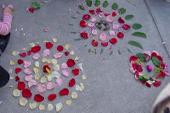
Andy Goldsworthy is a brilliant British artist who collaborates with nature to make his creations. Go to his websiteto view his gallery of breathtaking art. Teaching in a city school, I wanted to bring in a little nature against our urban pallet.
In groups of two, students were given about 10 old flowers (donated from a local florist) to work with...

Hiroshigi

Ando Hiroshigi Mural
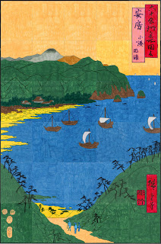Ando Hiroshige (1793-1858) was a master Japanese woodblock print artist who specialized in very poetic landscapes. He significantly influenced European artists from the 1870’s onwards, most notably van Gogh, Degas, Toulouse-Lautrec, Monet and Manet. The American painter Whistler even borrowed elements of Hiroshige’s style.
My pdf file is made up of a 30 pages and measures 36" x 54" when complete. You can purchase my pdf file with instructions for just $5. Click the “Add to Cart” button below to make your payment and receive download instructions.

Hockney

David Hockney Landscape
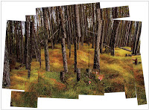
David Hockney, a contemporary artist living in Los Angeles, created photocollages in the 1980s, compiling a 'complete' picture from a series of individually photographed details. You can get a similar effect using one photo, cutting it up and loosely putting it back together again.
1. Start with a magazine photo, nature themes are nice to work with. Cut the picture into small square and rectangular sections, taking care to keep them still in order.
2. After a good mix of vertical and horizontal squares and rectangles are cut, glue them to a larger paper. Glue sticks work best as they minimize wrinkles. My goal was to keep the shapes somewhat in the same original placement, but overlapping and rotating them a bit.
Labels: 3rd grade, 4th grade, 5th grade, artist Hockney

Hundertwasser

Hundertwasser Flowers

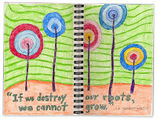
This is another drawing inspired by the Austrian abstract artist,Friedensreich Hundertwasser. His philosophy about nature is very reflective in his artwork, so I used his quote and love of wavy lines to jump start this journal page.
1. Draw wavy horizontal line, and then five random circles for the flower centers above it. All the centers had a stem drawn down, then lots of concentric circles around them.
2. Draw lots of wavy horizontal lines that imitated the horizon line, and jumped around each flower.
3. Add block letters below spelling out a quote from Hundertwasser. Trace all the lines with a thin black marker.
4. Using colored pencils, fill in the drawing in the style of Hundertwasser with some dark shading next to marker lines.
Labels: 2nd grade, 3rd grade, 4th grade, 5th grade, artist Hundertwasser,pencil crayon
4 comments:

APR 28, 2012

Hundertwasser Portraits
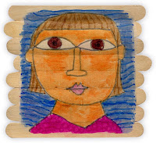
I’m hooked on the Vienna artist Hundertwasser, so I thought I would try combining his style with my popsicle portrait project. I think his art has a kind of layered marker look to it so it seemed like a good match.
1. It seems that Hundertwasser had a real aversion to straight lines, so I thought I would start with 8 un-straight jumbo popsicle stick glued to two back ones and let dry.
2. I traced the board onto dry wax paper just so I knew the size my drawing should be. Looking at Hundertwasser’s paintings, I tried his style of a very round head, large eyes, simple features and hair.
3. When the pencil drawing was done, I traced the lines with a gray marker, and then colored in all the shapes with Sharpie markers. In the past I have tried to not smudge the color together, but this time I let them smear all they wanted to. When the coloring was done, I cut the drawing out very close to the edges.
4. I mixed 50/50 glue and water and brushed a layer all over the board and the back side of the drawing. I placed the drawing on the board and brushed another layer of glue over the front. Any wrinkles were spread out to smooth before the glue dried.
5. After the glue was dry, I went back with the markers and added those trademark Hundertwasser lines wherever it seemed fit. The marker colors show up much brighter over the dry glue so they give some added punch to the picture.
Labels: 0 grade, 1st grade, 2nd grade, 3rd grade, 4th grade, 5th grade, artist Hundertwasser, markers, portrait
2 comments:

SEP 20, 2010

Contour Tree Drawing
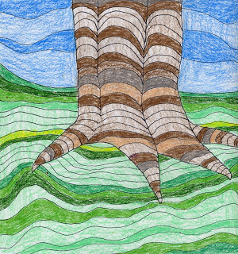I’m stilling enjoying the artwork ofFriedensrich Hundertwasser, who inspired this contour drawing of a tree trunk.
1. I used a square paper and drew the outline of a tree trunk with a few finger-looking shapes pointing down. After adding a few vertical lines for definition, I made a series of curved, or “jumping” lines going across and filling up the trunk.
2. I drew a curvy horizonal line, and then filled in the ground below with more horizontal wavy lines that jumped across the tree roots.
3. Lastly the sky got a few wavy lines also. When the pencil drawing was complete, I traced all the lines with a thin black marker.
4. I chose a main pencil color for the trunk, ground and sky. After filling in those areas with medium pressure, I went back and filled in some random lines with darker and lighter versions of each color.
CA Visual Art Standard: Creative Expression, Grade Three
2.3 Paint or draw a landscape, seascape, or cityscape that shows the illusion of space.
Labels: 3rd grade, 4th grade, 5th grade, artist Hundertwasser, CA Art Standard, pencil crayon
3 comments:

SEP 8, 2010

Back To School Portraits
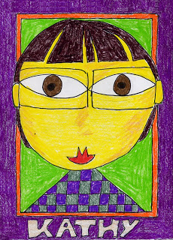I'd been looking for a different approach to self-portraits for a back-to-school project. I wanted something that would ask the students to see themselves in a new way, and create a colorful display that I knew the teachers would appreciate for their classrooms.Austrian artist Friedensreich Hundertwasser has an amazing life story, along with a very appealing style of abstract drawing. Click here to read more about him.
1. Start with a 9" x 12" paper, and trace the width of a ruler around the outside edges in pencil. Add another line about 1/4" away to make a narrow inner border.
2. Draw a very large circle that almost touches the top border and does touch the left and right. Wobbly circles are welcome! Shoulders may be straight or angled. Eyes are drawn by starting with a center dot, and then the football shapes that extend and touch the outside edge. Hair must be simple, simple, simple, using as few lines as possible. Names are drawn in block letters in the bottom border.
3. When the drawing is done, all lines are traced with a thin black marker.
4. Everything is colored in heavily with some good colored pencils. This sample is down Prismacolors.
Labels: 1st grade, 2nd grade, 3rd grade, 4th grade, 5th grade, artist Hundertwasser, pencil crayon, portrait
10 comments:

SEP 24, 2009

Hundertwasser Landscape
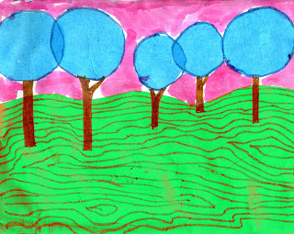I was inspired by one of Friedensreich Hundertwasser’s paintings to make this abstract landscape.
1. I cut a wavy rectangular shape of green tissue, large enough to cover the bottom 2/3 of the paper. A 50/50 mixture of water and glue was brushed under and over it to attach it to the paper.
2. I cut a bunch of round blue circles, and also glued them to the paper, overlapping a bit at times.
3. After the glue was dry, I used Sharpie markers to draw the tree trunks and lots of organic lines.
4. The sky was filled in with watercolor pencils, and then painted with water.

Labels: 2nd grade, 3rd grade, 4th grade, 5th grade, artist Hundertwasser

Indiana

Robert Indiana LOVE Letters
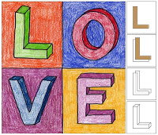
This project ties to a contemporary pop artist and makes a nice Valentine card too. Robert Indiana made afamous sculpture in the sixties that came to symbolize the peace movement.
PREP: I started with my school’s diecutter and made about a dozen of each letter cut out of chipboard. I cut 9" squares of drawing paper to go with the 3" tall letters.
1. Students fold the paper in half both ways to make 4 equal squares. Following the diagram, show the students how to first trace each chipboard letter in the center of each square.
2. Next, they move the letter up and to the right a bit and trace again. When complete, the front letter needs to have all the lines inside it erased.
3. All the corners are connected. The remaining letters are to be repeated in the same manner. The letter “O” is a bit of an exception as there are no corners, so only curved lines need to be drawn.
4. Lines are traced with a black marker and the letters and backgrounds are colored. If students color with medium pressure on the letter fronts, and then press hard to make shadows on the sides, their block letters will look even more 3D.
Labels: 4th grade, 5th grade, artist Indiana, lettering, pencil crayon

Pollock

A Jackson Pollack Pumpkin
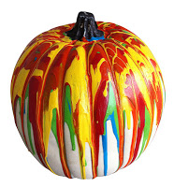
Want to show your neighbors how creative you are? Get this white pumpkin from Michaelsand pour lots of colorful acrylic paint over it. Let drip and dry for about 24 hours, and then add a coat of glossy Mod Podge for an extra shine. Voila! A pumpkinJackson Pollack would be proud to call his own.
Labels: 0 grade, 1st grade, 2nd grade, 3rd grade, 4th grade, 5th grade, artist

Rizzi

Back to School Portrait, Rizzi Style
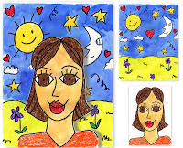
An American pop artist,James Rizzi, who achieved fame for his childlike style, vibrant colors and zany imagery. He accumulated quite a body of work over his lifetime, from album covers to airplane painting, so I find it easy to get inspired by his style.
1. A sheet of watercolor paper is filled with all the doodle shapes that students can think of. They can personalize their art by adding symbols of what they are interested in: musical instruments, sports equipment, etc. When the paper is really filled up, the lines are traced with a black Sharpie and small shapes are colored in heavily with crayons. The background is painted with watercolors. I opted to paint around the crayon so colors would stay bright.
2. A half-size piece of watercolor paper is used to draw the student’s self portrait. To steer the students away from making small heads, require that the top touch the top of the paper. The face is traced with a Sharpie and all but the skin is colored with crayons. Skin color is mixed and painted last. Let all art dry and press under heavy books overnight to flatten.
4. The head is carefully cut out with scissors. It is glued to the background with some small bits of foam core in between to make it look raised, or 3D.
Labels: 3rd grade, 4th grade, 5th grade, artist James Rizzi, portrait, watercolor

Johns
Jasper Johns, a master American artist, was the first to use everyday objects as his subject matter. One of his most famous paintings was just a grid with many numbers. Some math teachers find this art project helpful to have students practice lining up columns of numbers.
1. I printed up sheets of paper that were already divided into three columns of three squares. Ask the students to write single digit numbers only from the top left to the bottom right square in pencil.
2. The students are to trace all the numbers with a thick black marker.
3. Pass out lots of oil pastels and instruct students to color in each square, adding details as they desire.

Labels: 0 grade, 1st grade, 2nd grade, 3rd grade, 4th grade, 5th grade, artist Jasper Johns, oil pastel
No comments:

MAR 22, 2011

Jasper Johns 3D Painting
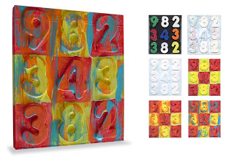
Jasper Johns is an American artist whose richly covered number paintings like this, rose to prominence in the 1950s. I created this project so students could make a miniature version, and recycle an old CD case as well.
1. Six 1 1/2" foam numbers or letters are arranged on an old CD case, the 1/4" thick variety. The students glue them down with white glue and let dry.
2. Gesso is needed to make the background opaque, so the entire CD front and sides are painted and let dry.
3. A second coat of gesso is painted and let dry.
4. Students use a pencil to draw the checkerboard lines between the numbers. They may choose two colors of acrylic and paint the board in a checkerboard style. The paint is let to dry.
5. Using a flat brush, students use one color of acrylic to “dry brush” a few vertical strokes in random spots.
6. Finally, students paint one last color in the same manner. Note: Restraint is needed here, the goal is to have a layered look with all of the colors still showing at the end.
Labels: 4th grade, 5th grade, artist Jasper Johns

Miro

Miro Watercolor Painting

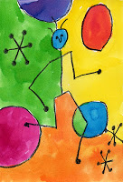
Joan Miro was a Spanish artist who developed a very whimsical style back in the 1930s. His painting called “People and Dog in Sun” is fun to imitate by drawing stick figures, stars and circles.
1. Draw one large stick figure in the middle of a sheet of watercolor paper, preferably in some action pose. Miro often repeated shapes in his work so add more shapes to your art but ONLY by using lines and dots. At least two of the shapes need to intersect (overlap) to make more closed shapes to color.
2. Trace the pencil drawing heavily with a black crayon.
3. I tried a new paint for this project - Dr. Ph Martin’s Inks. They are similar to watercolors but have a really intense pigment. They do stain clothes so I wouldn’t recommend them for young kids. Whatever you use, fill in all the shapes with a different color.
Labels: 4th grade, 5th grade, abstract, artist Joan Miro, watercolor

Kandinsky

Mini Diamond Kandinsky Painting
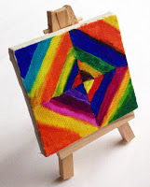
Imagine the fun of giving your friends a Kandinsky masterpiece – made by you of course. These are too fun and easy to give to everyone on your list.
1. Miniature canvases (2"x4", 3"x3") and easels are available at Aaron Brothers stores andjerrysartarama online.
2. Use a pencil to lightly draw two lines on the canvas, evenly dividing it into four sections. Using Sharpie Brush Tip Markers, color four triangles to make up the center diamond. Add lines of color around each until the canvas is full. For inspiration, here’s what Kandinsky’s original painting looked like.
3. Spray your painting with a clear gloss to make all the colors pop and display on your easel.
Labels: 0 grade, 1st grade, 2nd grade, 3rd grade, 4th grade, 5th grade, artist Kandinsky, markers
No comments:

DEC 12, 2012

Mini Masterpiece Painting
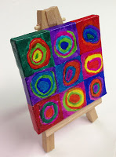
I was excited to find these mini canvases and easels online atjerrysartarama, but I noticed that Aaron Brothers sells them now too. At any rate, they are perfect for a little “Mini Masterpiece” project. And Kandinsky’s circle painting is perfect for even very young ones to imitate.
1. Mini canvases come in all different sizes – this one measures 3" x 3". Start by dividing the canvas into 9 equal boxes in pencil.2. Using Sharpie Brush Tip Markers, color a circle in the middle of each square. Outline it with another color, and another, until it almost fills the square. Finish by filling in each background while covering the outer edges of the canvas.
3. Spray your painting with a clear gloss to make all the colors pop and display on your easel.
Labels: 0 grade, 1st grade, 2nd grade, 3rd grade, 4th grade, 5th grade, artist Kandinsky, markers
No comments:

OCT 4, 2012

Kandinsky by Matson
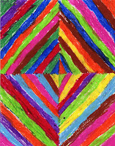
If you need a simple oil pastel project that works for many grade levels, try my “Kandinsky Colorweaver” project. I had prepared the paper with the center horizontal and vertical pencil lines so the students could jump right in making the colored diamonds. Thanks to Matson, a talented 1st grader for letting me share this beautiful artwork.
Labels: 0 grade, 1st grade, 2nd grade, 3rd grade, 4th grade, 5th grade,abstract, artist Kandinsky, oil pastel
2 comments:

MAY 16, 2012

Kandinsky Colorweaver
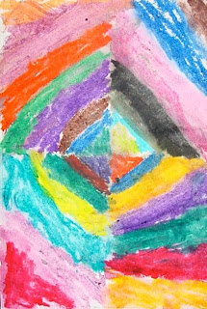Wassily Kandinsky made a beautiful painting called"Color Studies" back in the early 1900's that is fun to imitate with oil pastels instead of watercolor.
1. Distribute 9" x 12" pieces of art paper to students. Give them rulers to measure and draw pencil lines across the middle of the paper in both directions.
2. Ask the students to start in the center and with an oil pastel, draw an angle and fill in the triangle that is created. Continue around the center with drawing triangles, only changing colors each time.
3. Once a diamond is created, add bands of color around the diamond, always changing color on the pencil lines. Continue until the paper is filled with color.
This picture was made by a kindergartener in an afterschool class.
Labels: 0 grade, 1st grade, 2nd grade, artist Kandinsky, oil pastel
5 comments:

APR 16, 2012

Kandinsky Trees
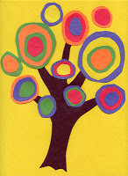
Kandinsky is perhaps most famous for his abstract circle paintings. But if you apply his idea to construction paper, some pretty interesting abstract results may occur.
1. Students cut out a tree trunk from black paper, more or less in the shape of a hand with five fingers outstretched at the top. It is glued to a background paper that offers a lot of contrast in color.
2. Lots of “circle leaves” are made by starting with the center circle cut from any color of paper. It is glued to another colored paper, cut out leaving an edge, and so on. The best results come from a variety of circle sizes and widths. Big, little, thick edges, thin edges – all are welcomed. These circles are glued on the branches until the tree is full.
Labels: 0 grade, 1st grade, 2nd grade, 3rd grade, 4th grade, 5th grade,abstract, artist Kandinsky
4 comments:

MAR 7, 2012

Outdoor Mural Update
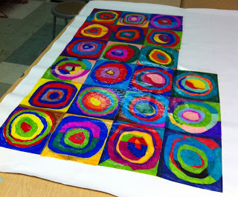
The colors still look great, but there was a fair amount of wrinkling going on due to the wet canvas shrinking in the middle and not on the dry white border. My next test is to see if wetting the outside edge with the 50/50 glue mixture will fix this, or if I just need to trim the mural out and get rid of the border. I can live with either as I’m so happy with the vivid, bright colors. Rough price for 50" x 60" piece of unstretched primed canvas? $15. Possibilities for outdoor art? Many! Final mural will be posted Monday.

An experiment – Dry Wax Paper panels glued to unstretched primed canvas. When complete, I’ll add grommets to the corners and hang outdoors to see how weatherproof it is. Note: This was created with Sharpies and my Kandinsky Circles Mural template.
Labels: 3rd grade, 4th grade, 5th grade, artist Kandinsky, markers
8 comments:

NOV 16, 2011

Kandinsky Watercolor Painting
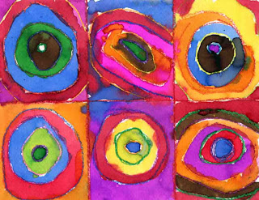
This project worked really well with my last afterschool watercolor class. And that was with over 40 kids (kinder through 5th) in one not-so-large art room! I'll add my tips on how to paint with these conditions below.
PREP: I pre-printed the grid lines on letter-size watercolor paper using my file posted HERE. About 80 spillproof cups with a variety of Dick Blick Student Liquid Watercolor paints were also set up before class.
1. With Kandinsky’s original painting in view, students drew concentric circles in each square with a crayon (no need to start with pencils). They were to press really hard to make a wall that would help keep colors from running together. They also traced the straight, computer-printed lines.
2. Using the liquid watercolors, students could take one color and use it randomly throughout their drawing, then go on to another. It would speed things up and allow paint to dry to minimize bleeding. I also now leave a roll of paper towels on each table to catch the inevitable spills. That’s it, I think this would make a great fundraising project.
Labels: 0 grade, 1st grade, 2nd grade, 3rd grade, 4th grade, 5th grade, artist Kandinsky, watercolor
2 comments:

MAY 17, 2011

Kandinsky Cityscape
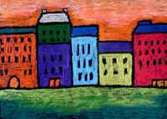
Kandinsky is perhaps best known for his abstract work, but I personally love the rich city life paintings he made, such as “Houses in Munich”.
1. I tried out some pastel chalk pencils for my sample, but I think you could get very similar results withconstruction crayons. I like the pencils as they can be sharpened and your fingers need never get covered in dust. Starting with a sheet of black paper, ask the students to draw in pencil a horizontal ground line. Afterwards, they are to draw a series of building rectangles that sit side by side. Windows and roofs may be added.
2. Ask the students to trace all of their pencil lines with the black pastel, going over each line at least twice to thicken it up.
3. When coloring in the buildings, they should choose the brightest and boldest colors – anything except the normal brown and gray. The sky and ground may be experimented on as far as mixing color, but the buildings should be just one flat color.
Labels: 2nd grade, 3rd grade, 4th grade, 5th grade, artist Kandinsky, chalk pastel
10 comments:

AUG 29, 2010

Kandinsky Oil Pastel Circles
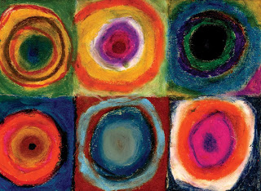Kandinsky pretty much invented abstract art back in the early 1900's, and his “Study of Abstract Squares” is a fun painting to imitate.
1. Start with a 9" x 12" paper, and have the students fold it in half; and then in thirds so that you have 2 rows of 3 squares.
2. Using oil pastels, students are to make a circle in the middle of each square fill it in. Then they gradually add rings of different colors around it, some thick and some thin until they reach the edge of the square. The corners are filled in as needed.
3. Students continue until all the squares are filled in. Remind them that slow, solid coloring is going to look much better than quick scribbles.
4. Young students may just practice their coloring with a variety of pastels. The 4th and 5th graders could be challenged to use different color theme in each square. For example: warm colors, cool colors, neutral colors, complementary colors, etc.
This art was made by a 2nd grader.
Labels: 2nd grade, 3rd grade, 4th grade, 5th grade, artist Kandinsky, oil pastel
8 comments:

APR 23, 2010

Torn Paper Kandinsky
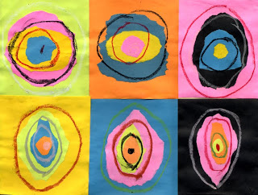Abstract art projects are great for those who feel that art is always about drawing, and may not always be so keen on their skills. Sometimes just making irregular shapes with color can produce beautiful results. These circles are created in the style ofKandinsky's "Farstudie Quadrate".
1. Give the students a horizontal 9" x 12" sheet of white paper. Then offer many colored rectangles (4.5" x 4") for them to choose from. They may select six, and these are to be glued down on the white paper, in two rows of three to make a grid.
2. Lots of additional (4.5" x 4") rectangles may be distributed. The students are to tear (no cutting!) an oval that fills one rectangle. Then they are to tear sequentially smaller ovals that fit inside, at least three ovals in each. As the pieces are torn, they may be glued down with a glue stick. Continue until all the rectangles are filled.
3. When the glue is dried, distribute oil pastels. Ask the students to choose colors that contrast with their paper, and then draw 2-3 ovals in each rectangle.
Labels: 4th grade, 5th grade, artist Kandinsky, oil pastel

Haring

Keith Haring in Chalk and Glue
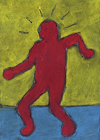
Keith Haring (1958 – 1990) was an artist and social activist whose work responded to the New York City street culture of the 1980s. His simple and colorful figures are a great style to imitate when studying body proportions.
1. I gave each student a 9" x 12" sheet of black paper, and a cardboard rectangle about 3" x 5", which was centered on the paper and traced. My goal was just to have the students use this as the torso of the body, and they were to add "action" arms and legs in whatever combination they saw fit. The tendency is for them to draw small, so they need to be reminded that the middle of the torso would be the waist, so any elbows in their drawing should line up accordingly. The legs also need to be long and wide, and fill the bottom of the paper. Lastly, "energy" lines were added around the head, along with a simple horizon line.
2. After the pencil drawing was done, and the box lines were erased connecting the torso and the legs and arms, the students carefully traced the drawing with white glue. Let the art dry flat for at least 24 hours.
3. Show the students examples of Haring's simple primary colored figures. They are to use chalk pastels accordingly, coloring and blending with their fingers to get coverage all around the glue lines.
CA Visual Arts Standard: Grade Four
2.2 Use the conventions of facial and figure proportions in a figure study.
Labels: 4th grade, 5th grade, artist Keith Haring, chalk pastel
3 comments:

MAY 16, 2011

Keith Haring Drawing
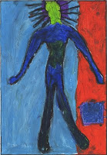
Keith Haring was one of the first artists to mix street art with the world of high art back in the 1980s. He got his start by decorating billboards in New York subway stations.
1. I had some drawing manikins that I inherited from a previous teacher, and figured out how to remove the base and silver pole. The body was placed on a large drawing paper, arranged in a desired action pose and traced. This can be a bit awkward, but I encouraged the students to just make a simple tracing and not worry about details.
2. A horizon line may be added, but the body is to remain simple with no face or details. The body and background is colored heavily with oil pastel. When complete, the body may be outlined with a black pastel.
Labels: 3rd grade, 4th grade, 5th grade, artist Keith Haring

Johnson

Ode to William H. Johnson Mural
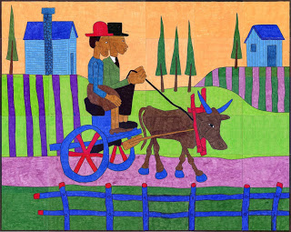
In celebration of Black History Month, I've created this mural in the style of William H. Johnson (1901-1970), a very talented painter who had a difficult life. He came to be widely admired for his primitive style and bright colors, but sadly, only after he had passed away. I love the rural scenes that he often painted, so I’ve created a new mural with big, flat shapes in his style of drawing that you may color however you’d like – the bolder and brighter, the better.

This template contains 25 pages and measures 50"x 40" when complete. A color key is included, instead of color callouts, as this is an original artwork and may be colored any way you’d like. Click on the image above to see a preview of the template pages.

You can purchase my pdf file with instructions for just $5. Click the “Add to Cart” button to make your payment via Paypal and receive download instructions.

Klee

Scratch Away Klee
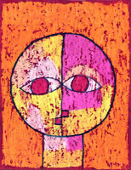
Paul Klee was a Swiss/German painter of abstract art. His Seneciopainting is made of simple geometric shapes, and is a lot of fun to imitate.

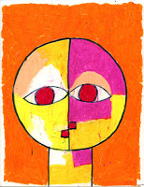
1. Trace a round shape like a dish to make a large round circle in the middle of the paper. Add a neck and mouth using only straight lines. Draw two eyes that touch each other in the middle. Trace with a Sharpie marker, and color all heavily with oil pastels.

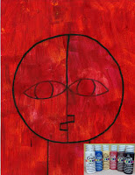
2. Paint over all with acrylic paint. I recommend one color to keep things simple. Let dry.

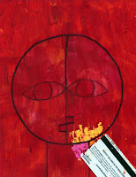
3. Use an old plastic card (like credit or gift card) to scrape the paint away. Keep scraping until the art shows through, but a bit of the paint color is left for an aged effect.
BEWARE: After completing this project with many classes, I’m finding that at least one or two in each are really difficult to scrape the paint away. Maybe if the oil pastel is not colored too heavily, it keeps the paint from separating from the paper? I’m not sure, I just recommend tests and careful watch of kid’s coloring before painting.
Labels: 0 grade, 1st grade, 2nd grade, 3rd grade, 4th grade, 5th grade, artist Paul Klee, oil pastel, paint
6 comments:

SEP 3, 2012

Oil Pastel on Acetate
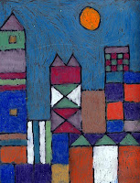I love the way oil pastels look on a sheet of acetate, backed with a nice black piece of construction paper. Paul Klee’s City Picture can a lot of fun to imitate in this style with just a few aids.
1. Download a background grid paper I made HERE. Print on white paper and draw a very geometric stack of buildings. Triangles may be added to the squares, along with one circle moon in the sky.
2. Tape a piece of acetate to the front of the grid drawing and trace their drawing on the acetate with a black Sharpie marker.
3. Flip the drawing over and color in all the shapes with oil pastel. Coloring on the back will keep all the black lines intact, even if you color over them a bit.
4. Lastly, the acetate drawing is placed in front of a piece of black paper (shiny and clean side up, pastel to the inside) and taped with invisible tape.
Labels: 2nd grade, 3rd grade, 4th grade, 5th grade, artist Paul Klee
4 comments:

AUG 20, 2012

Paul Klee Castle Drawing
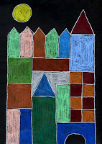
Paul Klee was one of the great colorists in the history of painting. I developed this project that imitates his abstract “Castle and Sun” painting by having students trace cardboard shapes and fill them in with colored pencils.
1. Give each student a piece of black paper, a pencil and half a dozen or so cutout square, rectangle and triangle cardboard shapes. I made lots of shapes that were all based on 1" proportions. My sample uses 2" squares, 1" x 2" rectangles (some with triangle tops) 3" x 2" rectangles, a 3" bridge, and a 2" circle.
2. Starting at the bottom, the students are to stack and trace the cardboard shapes until they have built a castle to their liking. A sun is also added somewhere in the sky. After the drawing is done, they trace all the pencil lines with a white colored pencil.
3. All the shapes are filled in with colored pencil. Tip: If you can, buy some good black Artagain paper which won’t face before your very eyes like the school-regulated construction paper does. There’s nothing like good materials to make good art!
Labels: 3rd grade, 4th grade, 5th grade, artist Paul Klee
4 comments:

JUL 13, 2010

Oil Pastel Klee Portrait
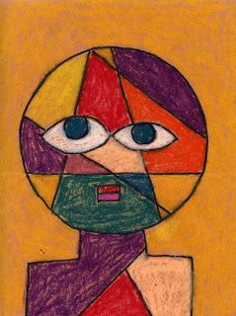Paul Klee was a Swiss artist from the early 1900’s who liked to turn things into simple geometric shapes. This sample is based on his“Head of A Man” a classic example of his philosophy.
1. Make a 7" round cardboard template for the students to trace in pencil in the center of a brown or tan 9" x 12" paper. Then have them add the neck and shoulders using straight lines and angles, only.
2. To draw evenly spaced eyes that touch, I often have the students first draw three evenly spaced dots that they connect with curves. Circles are added inside. Using a ruler, show the students how to draw about 5 intersecting lines across the face that “jump” over the eyes. The body may have 2 or 3 lines added also. The mouth is just a simple rectangle with a horizontal line through it.
3. When the drawing is complete, all the pencil lines are traced with a thick black Sharpie marker.
4. All of the closed shapes are now colored in with oil pastels. The goal is to have lots of different colors without any of the same touching each other.
CA Visual Arts Standard: Creative Expression, Kindergarten
2.6 Use geometric shapes/forms (circle, triangle, square) in a work of art.
Labels: 0 grade, 1st grade, 2nd grade, 3rd grade, 4th grade, 5th grade,abstract, artist Paul Klee, oil pastel
4 comments:

APR 7, 2010

Paul Klee Abstract Castle
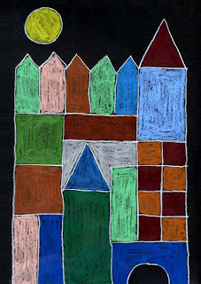Paul Klee was one of the great colorists in the history of painting. I developed this project that imitates his abstract“Castle and Sun” painting by having students trace cardboard shapes and fill them in with colored pencils.
1. Give each student a piece of black paper, a pencil and half a dozen or so cutout square, rectangle and triangle cardboard shapes. I made lots of shapes that were all based on 1" proportions. My sample uses 2" squares, 1" x 2" rectangles (some with triangle tops) 3" x 2" rectangles, a 3" bridge, and a 2" circle.
2. Starting at the bottom, the students are to stack and trace the cardboard shapes until they have built a castle to their liking. A sun is also added somewhere in the sky. After the drawing is done, they are to trace all the pencil lines with a white colored pencil.
3. All the shapes are filled in with colored pencil. Tip: If you think this may be a “keeper” project and you have the resources, buy some good black Artagain paper which won’t face before your very eyes like the school-regulated construction paper does. There’s nothing like good materials to make good art (sometimes!)
Labels: 2nd grade, 3rd grade, 4th grade, 5th grade, artist Paul Klee, pencil crayon
6 comments:

FEB 22, 2010

Paul Klee Doodle Drawing
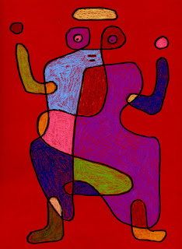One way to appreciate the masters is to try to copy them. A famous painting of Paul Klee’s titled “The Grooms Arrival” looks like one simple doodle drawing filled with different colors, which I thought my students would enjoy imitating.
1. I studied “The Grooms Arrival” to come up with a continuous line drawing for the ‘body’ that would pretty closely resemble the original. Using the board in my room, I had the students follow along with me as I drew my doodle example very slowly. They drew in pencil on some new paper I found – Staples® Bristol Board. (It comes in some very nice colors and is fade resistant too). The goal was to have them draw a large doodle with several crossover lines. When the ‘body’ was done, they could add arms and feet that also crossed over the body in some fashion. A hat, eyes and mouth were added.
2. With the drawing complete, the lines were traced with a fat black marker. Staples came through again with their own fat chisel-tip permanent markers that were much less expensive than Sharpies.
3. All of the closed shapes were colored in with colored pencils. My students used my Dick Blick pencils, which work well on colored paper. Construction Crayons would be good too, I’m sure.
Labels: 2nd grade, 3rd grade, 4th grade, 5th grade, artist Paul Klee
4 comments:

FEB 14, 2010

Paul Klee Oil Pastel Landscape
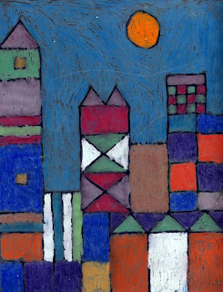I love the way oil pastels look on a sheet of acetate, backed with a nice black piece of construction paper.
1. Create or buy grid paper and show students how to draw a simplified city skyline with lots of squares, rectangles and triangles.
2. Have the students tape a piece of acetate to the front of their grid drawing and show them how to trace their drawing to the acetate with a black Sharpie marker.
3. The students are to color in the building shapes with oil pastels on the back side of acetate.
4. Lastly, the acetate drawing is placed in front of a piece of black paper to be displayed and enjoyed!
Labels: 3rd grade, 4th grade, 5th grade, artist Paul Klee, oil pastel
9 comments:

OCT 11, 2009

Paul Klee Portrait
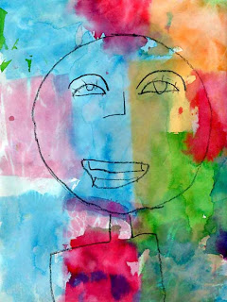Paul Klee was a Swiss artist from the early 1900's who liked to turn things he saw into simple geometric shapes. His “Head of A Man” is a classic example of his philosophy.
1. In the center of a 9" x 12" sheet of paper, have the students draw a 6" circle, using a cardboard template. Below that the neck and shoulders can be drawn, but only using straight lines and angles.
2. The face may be drawn in pencil, but again only using very simple lines. Trace all with a dark crayon, pressing firmly.
3. Cut up various sheets of tissue paper, in about 3" squares. With a cup of water and a paint brush, the students are to dampen the white paper, and place up pieces of tissue on top in a grid-like format. Once the paper is covered, the tissue may be picked up and thrown away. The student will find that the tissue color has bled to the paper in irregular shapes. It is wise to test tissue paper with water first as some bleed more than others.
Labels: 0 grade, 1st grade, 2nd grade, 3rd grade, abstract, artist Paul Klee,portrait

Klimt

Klimt Watercolor Tree
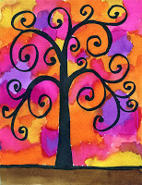
I was so happy to find this idea atArtsonia from Cedar Creek Elementary. It’s perfect for little ones just figuring out how to draw and paint. All you need is one permanent marker and some overlapping watercolor paint to make a really stunning picture.
1. Draw a ground line and the center tree trunk with a pencil. Add curly branches to the left and right. Add more curls wherever they fit.
2. Trace all the pencil lines with a chisel-tip black Sharpie marker. Add some extra thickness to the tree trunk and beginning of the branches.
3. Paint the ground one color (I love Dick Blick Liquid Watercolor paints). Paint splotches of color all over the tree and background. Overlap the splotches a bit so that the colors run together.
Labels: 0 grade, 1st grade, 2nd grade, 3rd grade, 4th grade, 5th grade, artist Klimt, watercolor
6 comments:

MAY 11, 2012

Draw Klimt’s Tree of Life
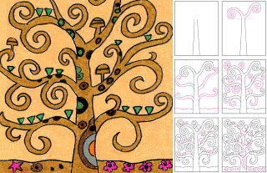
Gustav Klimt (1862-1918) was an Austrian painter and one of the most prominent members of the Vienna Art Nouveau movement. His wonderfully abstract “Tree of Life” can be fun and relatively easy to draw when you break it down into steps.
1. Draw center tree trunk.
2. Add one curvy branch to the right and one to the left.
3. Center two more curvy branches on either side. Draw the ground line behind the tree.
4. Add small curvy branches wherever space allows.
5. Add small abstract triangle leaves and mushroom shapes.
6. Add abstract designs inside the tree and on the ground. Erase the lines where the the branches are added on.
7. Trace all the lines with a permanent black marker. Color the tree and background as desired. Gold and rich colors were often featured in Klimt’s work.
Labels: 3rd grade, 4th grade, 5th grade, abstract, artist Klimt, oil pastel
2 comments:

MAR 21, 2010

Gustav Klimt Drawing
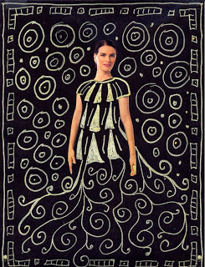An Austrian painter, Gustav Klimt lived in the early 1900's and started his career as a decorator. He is probably most famous for his painting named"The Kiss".
1. The first step is to give the students black construction paper, magazines with lots of people in them, scissors and a glue stick. Instruct the students to look for a person in the magazine that has exposed arms. They are to cut out the head and arms as three separate pieces.
2. The body parts will then be arranged on the black paper in the same manner they were in the magazine. Have the students carefully glue these down with a glue stick.
3. The fun part! You'll need some gold paint markers, which are not cheap, but they are SO fun to draw with. Explain again to the students that Klimt was considered a master at both decorating and painting and they are to fill in their person with an amazing, over-the-top piece of clothing and then lots of pattern all around the background until there is no more room. NOTE: The paint markers are not rated safe for young children. Use at your discretion with students that you trust will not stick them in their mouth or give classmates gold manicures.
Labels: 4th grade, 5th grade, artist Klimt, markers

Lewis

Maud Lewis Cat Painting
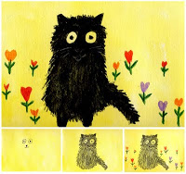
Renowned Nova Scotia folk artist Maud Lewis (1903 – 1970) painted colorful scenes of rural Nova Scotia using random art supplies and painful hands as a result of juvenile rheumatoid arthritis.
1. Wet a 12" x 9" piece of watercolor paper, and paint the background bright yellow. Let dry. Using watercolor pencils (like Prismacolor), draw the cat eyes, nose and mouth as shown with a black pencil.
2. With the same pencil, fill in the area around the eyes with short dark strokes to make a head. Add ears, and an oval-shaped body below. A tail may be added to one side.
3. Heart-shaped flowers are drawn around the cat as desired.
4. Use a small wet paint brush to go over the pencil, which will turn the color into paint. Make short strokes in an outward direction to make the fuzzy edges of the cat. Black legs may be added to the bottom. When dry, trace over the mouth lines with a white pencil, and add whiskers.
Labels: 0 grade, 1st grade, 2nd grade, 3rd grade, 4th grade, 5th grade, artist

Lichtenstein

Lichtenstein Style Portraits
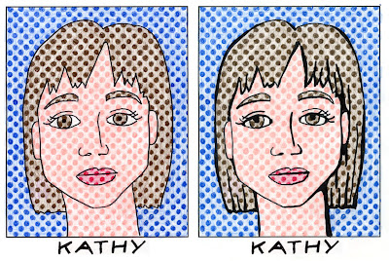
Roy Lichtenstein was a prominent American pop artist who favored old fashioned comic strips as a subject matter. By using a pre-printed paper full of empty dots, you can make your own portrait – complete with graphic marker shading.
1. You can download my pdf template of empty dots HERE. Start by lightly sketching your face with a pencil. Remember, the eyes go in the middle of the head, not up near the top!
2. Trace all the lines with a black Sharpie marker.
3. Fill in the dots with the desired pencil crayon colors. This may take some time, but neatly colored dots will make a successful picture. Also add some light background shading of each color.
4. Using the Sharpie marker again, add some thick lines wherever you think shadows may happen, as shown by image on the right. Be sure to leave some of the lines thin so you have variety.
Labels: 4th grade, 5th grade, artist Lichtenstein, pencil crayon

Magritte

An Eye for Magritte
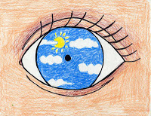
René Magritte was a Belgian surrealist artist who became well known for a number of witty and thought-provoking images. He wanted to challenge viewers to think about what they were looking at and to ask themselves “What does this painting mean?”
1. Take an old CD and trace it in the center of an 8.5" x 11" paper. Add lines around the circle to turn it into an eye, including eyelashes.
2. Trace all the pencil lines with a black marker.
3. Draw an image inside the eye which reflects something you like to look at. This could be anything BUT the drawing of the inside of an eye. The more mysterious, the better! Color all the shapes with colored pencils.
CA Visual Art Standard: Grade Five
2.7 Communicate values, opinions, or personal insights through an original work of art.

Mailou Jones

Lois Mailou Jones-style Drawing
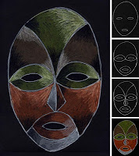This Lois Mailou Jones-inspired drawing is in honor of Black History month (coming up in Feb). During Lois’ remarkable life, she painted, designed masks, textiles and stained glass windows, traveled the world and never stopped learning. Her “Les Fetiches” art has a style that is fun to imitate.
1. Starting with a black sheet of paper (I prefer art paper, not construction...
Labels: 3rd grade, 4th grade, 5th grade, artist Lois Mailou Jones, Black History Month, CA Art Standard, drawing

Matisse

Mini Matisse Painting
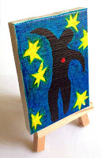
Matisse was a French artist, known for his use of color and organic shapes. You can see his painting that inspired me HERE.
1. Miniature canvases (3"x3") and easels are available at Aaron Brothers stores and jerrysartarama online. Use a pencil to lightly draw lines on the canvas in the style of any Mondrain painting.
2. Using Sharpie Brush Tip Markers, color the light colors first. Fill in the black last as the markers color so well they tend to smear if bumped together.
3. Spray with a clear gloss to make all the colors pop, and then give someone special an original masterpiece for the holidays!
Labels: 2nd grade, 3rd grade, 4th grade, 5th grade, artist Matisse, Cre8time projects, markers
No comments:

FEB 25, 2012

MAR 8, 2011

Overlapping Matisse Shapes
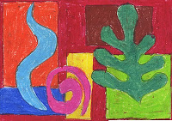
I combined an overlapping lesson with Matisse-like shapes to make a colorful drawing exercise. You could begin by talking about how Matisse didn’t start painting until he was about 20 years old, but then would paint morning, noon and night for pretty much the rest of his life. He eventually became a key figure in the world of modern art.
1. I had a lot of scrap chip board on hand and first gave the students several squares and rectangles they could spread out on their paper and trace for the background.
2. I passed out organic-looking shapes I had cut from posterboard to imitate the leafy and flowery shapes in many of Matisse’s most famous paintings. My students were just kinder and 1st grade, so they got a lot of tracing practice. Older students could draw these shapes freehand. To make the organic shapes look as if they were all in front, all lines inside of them were erased before coloring.
3. All shapes were traced in oil pastels and colored in as solidly as possible.

Labels: artist Matisse, oil pastel
1 comment:

JAN 25, 2010

Matisse Pattern Landscape
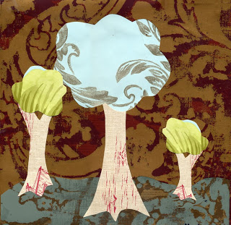Henri Matisse, an important French artist, loved all kinds of patterns. Not only the decorative forms he created, but also reproductions of tapestries, embroideries, silks and more. A recent donation of leftover wallpaper inspired this project.
1. I first gave each student a 12" square of chip board for mounting. I passed a variety of wallpapers cut in 12" squares.
2. I asked the students to first choose one main wallpaper for their background and glue it to the chipboard with heavy use of a glue stick.
3. The next step was to choose a ground color and cut a horizon to glue over the background paper.
4. I showed the students how to draw a tree trunk on the back of the wallpaper to cut out and glue it over the ground and background. Tree tops were drawn on another piece of wallpaper to cut out and glue over the top of the trunks. Repeat this step in various sizes. Simplicity of all the shapes is encouraged.

Labels: 2nd grade, 3rd grade, 4th grade, 5th grade, artist Matisse
6 comments:

JUN 1, 2006

Ode to Matisse Xmas Diagram
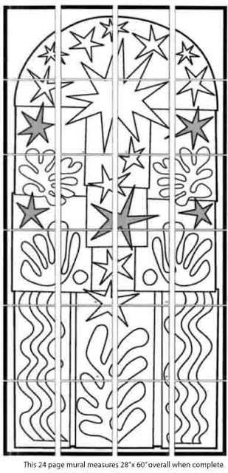
Labels: artist Matisse
Modigliani

Modigliani Style Portrait
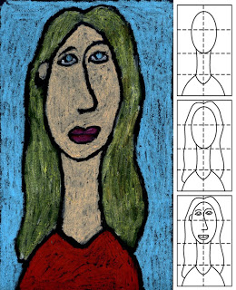
Amedeo Modigliani was a late-century European artist who never lived to see his success, but his paintings are some of my all-time favorites. I love his portraits with elongated faces in soulful colors.
1. Start with a tall 9" x 15" sheet of black paper. Fold the paper in half three times to make 8 equal sections as shown. Draw a head, neck and body as shown on the diagram.
2. Draw hair around the head as needed.
3. Modigliana drew his faces in stretched proportions as the eyes usually sit in the middle of the face. Draw your eyes near the top of the head, and the mouth near the bottom. Continue with a nose and eyebrows.
4. With a black oil pastel, trace the pencil lines using a lot of pressure to make a thick line. Fill in the skin, hair and clothes with more pastel. If some of the black lines get covered up, trace all again when complete.
Labels: 2nd grade, 3rd grade, 4th grade, 5th grade, artist Modigliani, oil pastel,portrait
2 comments:

JAN 2, 2012

Oil Pastel Portraits – Modigliani Style
Amedeo Modigliani was famous for his elongated and elegant portraits, painted in Paris back in the early 1900s. Heads and necks were long and narrow, giving his subjects a very graceful look.
1. Starting with a 7" x 12" paper, I made light pencil marks approximately 1/3 down the center of the paper, and another third down again. To draw the head, I made an oval that filled up the top 2/3 of the paper. A neck filled the bottom third, along with curved shoulders.
2. At this point, you could remind students of the “normal” placement of features on a face, namely the eyes belong in the center of the head, and the mouth at the bottom 1/8". To make a Modigliani face, the eyes need to be above the center line, and the mouth extra close to the chin. I drew in a long nose in the space that was left. Hair and ears can be filled in as desired.
3. All the pencil lines are traced with a thin black marker, including a signature on the shirt.
4. Modigliani also used a lot of dark and rich colors, so students may be asked to follow that palatte.
CA Visuals Arts Standard: Creative Expression
2.2 Use the conventions of facial . . . proportions in a figure study.
Labels: 3rd grade, 4th grade, 5th grade, artist Modigliani, oil pastel
1 comment:

JAN 12, 2011

Another Modigliani Portrait
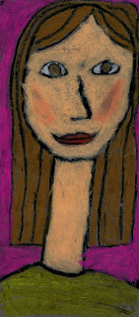
I can’t tell you how much I adore this Modigliani-style portrait that a 4th grader made today. I find her Mona Lisa smile and hint of blush so sweet that I could look at it all day. Beautiful work, Francesca C.
If you’d like directions on this project, see my posting here.

Note: My curriculum plan for this month is doing a series of self-portraits. First week is a portrait with standard proportions (eyes in the middle of the head, nose halfway down, etc). Second week is this Modigliani drawing with exaggerated proportions. Third is a lesson about Picasso and with his cubism portraits, which I have posted about here.
Labels: 4th grade, 5th grade, artist Modigliani, oil pastel

Modrian

Mini Mondrain Painting

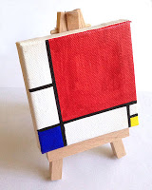
Piet Mondrian was a compulsive Dutch artist who could never bear to see anything disordered or untidy. It’s not difficult to see that in his artwork, which you can see HERE.
1. Miniature canvases (3"x3") and easels are available at Aaron Brothers stores and jerrysartarama online. Use a pencil to lightly draw lines on the canvas in the style of any Mondrain painting.
2. Using Sharpie Brush Tip Markers, color in the rectangles with primary colors.
3. Trace all the art with a black marker.
3. Spray with a clear gloss to make all the colors pop, and then give someone special an original masterpiece for the holidays!
Labels: 2nd grade, 3rd grade, 4th grade, 5th grade, artist Mondrian, markers
1 comment:

AUG 29, 2012

Mondrian Watercolor Painting

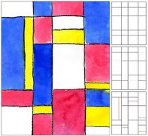
Piet Mondrian became a master of geometric shapes in abstract art. There are many ways to imitate his style of painting, but I like this one best as the crayon naturally creates a wall between the watercolors.
1. With a ruler lightly draw about four parallel horizontal lines across a piece of watercolor paper. Draw about four vertical lines.
2. Randomly erase about three or four “pieces” of the horizontal lines.
3. Add about five lines, in any direction, chopping up any the the large rectangles to make some small ones. The goal is to have relatively even amount of large, medium and small shapes when complete.
4. Trace all their lines, pressing heavily to make a dark line with a black crayon.
5. Paint in the squares with red, blue and yellow watercolor paint. Try to spread out and visually balance all the colors (including white).
Labels: 3rd grade, 4th grade, 5th grade, artist Mondrian, watercolor
4 comments:

MAY 18, 2011

Mondrian Abstract Circuitboard
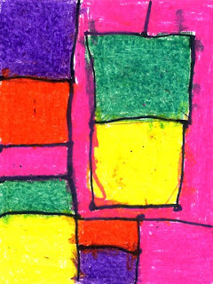This project can introduce young students to the idea that not all art has to be about recognizable images. Some can just be about lines and color, like the amazing art of Piet Mondrian.
1. Distribute standard size drawing paper. To get a random set of lines, first ask the students to draw a large box anywhere on their paper. Then they are to connect it to the paper edge with either a vertical or horizontal lines (no diagonals on this project!) Next comes one complete vertical and horizontal line. Lastly, they are to pick one of the sections they have made and split it up into small shapes with about 4 or 5 lines. The goal is for each image to be unique, with a combination of large and small areas. Lastly, wherever lines intersect, the students are to draw a large dot to stand for the "connector" on their circuitboards.
2. All pencil lines should then be traced with a fat black marker.
3. And finally, all the shapes are to be colored heavily with oil pastels. Ask the students to consider balance in their artwork when coloring, so that the colors they choose are evenly spread throughout their picture.

Labels: 1st grade, 2nd grade, abstract, artist Mondrian, oil pastel

Monet

Monet Water Lilies
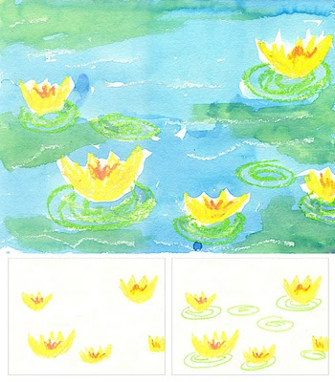
Claude Monet (1840-1926) painted directly from nature and revealed that even on the gloomiest of days, an infinite number of colors can and do exist. To capture these fleeting hues, Monet created a new painting technique using short brushstrokes filled with individual color. The result was a canvas alive with painterly activity, the opposite of the smooth blended surfaces of the past.
1. I presorted some oil pastels so that students had only yellow, peach, pink, light green and white available to choose from. As a follow-along drawing, I asked them to first color one large yellow lily (which is much the shape of a tulip) and then one medium and several small on a large piece of watercolor paper. Peach pastel was added on top of each, as a kind of shadow, and then pink for a center. Light green ovals were drawn around the bottom of each lily. Lastly, lots of squiggly lines were added with the white pastel to look like waves.
2. I gave the students liquid blue watercolor, and asked them to paint over everything except the flowers. While the paint was still wet, they had a chance to add a bit of green watercolor in any areas they liked.
Labels: 0 grade, 1st grade, 2nd grade, 3rd grade, 4th grade, 5th grade, artist Monet, watercolor

Monet Pastel Iris Drawing
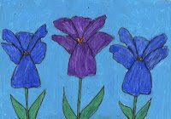
An on-going dilemma I face is how to help students draw new shapes, without giving them too much help. My current solution is to give them partial templates, so that they all have a good starting place to build upon. With these Monet-inspired Irises, the students were given just the center lower leaf as a template, and they had to follow my instructions to draw the rest of the flower.
1. The students used a 12" x 9" piece of paper, and a cardboard template for the lower Iris leaf, which looked a lot like an upside-down duck foot. I had them trace the petal in the center of their paper. Next, two more curved leaves were drawn to the right and left of that petal. Lastly, a center leaf is indicated with just one wavy line on top, and some small stamens were added in the center. After the flower was done, more were added to the right and left as space allowed.
2. When the drawings were complete, they were traced with a black Sharpie marker. I've learned that water-soluble markers will look OK initially, but bleed into the pastels over time. Not good if you want to keep all the nice detail your students have drawn.
3. After the drawings were complete, students were allowed to use blue or purple oil pastels to color their flowers, along with orange or yellow stamens. White pastel etched over the petals added a smudgy, Impressionist look to their art.
Labels: 3rd grade, 4th grade, 5th grade, artist Matisse, artist Monet
1 comment:

Munch

Student’s “Scream” Art
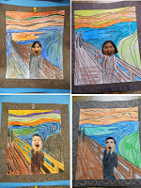
“My class did our own version of “The Scream.” I have a “Start Exploring Masterpieces” coloring book by Mary Martin (great book for easy art lessons). I made copies of the picture and had students color it with crayons. Then we glued them on brown construction paper and decorated the border to look like a frame. I took "screaming" pictures of my students, which they cut out and glued to the picture. Each one was unique and my students really enjoyed this project. ” — Kate Miller
Labels: artist Munch, kid's art gallery
No comments:

OCT 15, 2011

Pumpkin Festival Photo Op
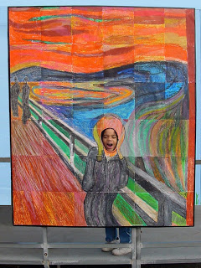My school's biggest annual fund raiser is our Pumpkin Festival. With Halloween themes galore, I decided to blow up my mural of “The Scream” to create a fun photo op.
1. I printed my mural templates at 130% on 11" x 17" 65 lb. cardstock.
2. The pages were colored in, trimmed off and taped together from behind. I used clear packing tape to handle the additional size and weight.
3. To mount, I taped together four 30" x 40" sheets of 1/2" thick foam core. I taped over the seams on both sides with duct tape and reinforced the back by taping down four 3' wood dowels.
4. I layed out the finished mural on the front to measure the excess foam core. I marked my cutting lines and trimmed with a box cutter.
5. With the mural now laying flush to the edges of the foam core, I folded over half of the mural, applied spray adhesive to the mural back and foam core and rolled the mural back into position. I then glued the other half down in same manner.
6. I used black duct tape to smooth the outer edges while creating a nice, even frame.
7. I used my box cutter to trim an oval out of the face and added a little more duct tape to smooth over the back edge of the oval.
Labels: 4th grade, 5th grade, artist Munch, halloween, oil pastel
4 comments:

OCT 4, 2011

Munch’s “The Scream” Self Portrait
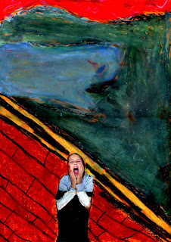There’s no denying the popularity of Edvard Munch’s “The Scream”. It’s one of the most famous paintings from theExpressionist movement, and is fun for students to imitate.
1. A discussion of the painting is a good place to start, followed with digital photos of each student making their own “scream” face. Make color prints of each photo.
2. I gave the students some colored art paper, had them cut out their colored head and arms, and glue down to the bottom right corner.
3. The original painting has lots and lots of different colors, but there are some basic shapes that I indicated to the students. The sky is made of mostly warm colors, the water dark blues, and the ship lots of browns. I asked the students to outline these shapes on their paper, and then go to town filling them up with layers of colors indicated. This was a very popular project as both the students and homeroom teacher loved the results.
Labels: 4th grade, 5th grade, artist Munch

Nevelson

Louise Nevelson Found Sculpture
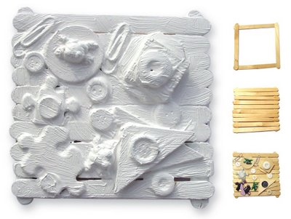Louise Nevelson was a creator of wood assemblages made from found objects doused in paint. She worked hard to get recognition in the mostly male art world, but wished to be seen as more than just a ‘woman artist’.
1. I glued the basic square as shown ahead of time for the young students to keep things sturdy. Give each student white glue and enough sticks to fill in the box as shown to make a flat board.
2. Collect a bunch of small items (like buttons, paper clips, puzzle pieces, etc.) that have different shapes and textures and have the students glue them down with generous amounts of white glue. Let dry overnight.
3. If you have the budget, paint heavily with white or black acrylic paint so the art has a shine when complete. If not, tempera paint will work too, you just may need more coats to block out color below.
Labels: 0 grade, 1st grade, 2nd grade, 3rd grade, 4th grade, artist Nevelson,popsicle sticks

O’Keefe

O’Keeffe Pastel Flower

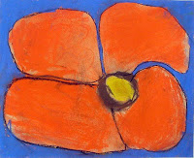
Georgia O'Keeffe had a long and varied career but is mostly famous for her oversized flower paintings.
1. Let each student choose from a collection of large flower photos, possibly from old calendars. Instruct them to first sketch their flower in pencil, large enough to go near or even off the edges of the paper.
2. Chalk pastels are colored and blended into the paper. Recommend that large areas be colored first, and fine details on top go last. The background looks nice when colored in with a contrasting or complementary color.

Labels: 2nd grade, 3rd grade, 4th grade, 5th grade, artist O'Keeffe, chalk pastel
No comments:

JUN 1, 2006

O'Keeffe Diagram
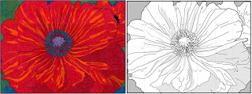
Labels: artist O'Keeffe
No comments:

Oldenburg

Oldenburg Style Installation Art
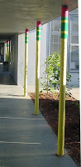Most installation art is intended to have you look at your environment with a different perspective. Claes Oldenburgwas famous for depicting ordinary objects in a monumental scale. I recently directed a temporary wrap job on our school’s outdoor posts to give our hallway a new look for a few weeks.
1. The metal posts were wrapped in yellow paper and taped in place. I had the students cut green panels of felt that wrapped the posts and were about 10" wide, and pink rectangles that measured about 5" wide. The two were overlapped about an inch and glued together.
2. Two long yellow strips of felt, about 1 1/2" wide were cut and glued in the middle of the green panel. When dry, the entire panel was wrapped around the top of each post and taped with clear packing tape.
Labels: 4th grade, 5th grade, artist Oldenburg

Picasso

Cubist Paper Bag Costume

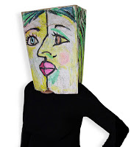
A Halloween book that included faces on paper bags inspired my “Cubism” costume.
I used a regular brown grocery bag, and started by drawing the split face on one side with a black pastel. For more specifics on how to draw the two-sided face, check out my post here. After the features were drawn in black, I colored white pastel to fill in the background and cover over any logo art. (My Portfolio® brand pastels are pretty opaque.) I continued drawing the hair around the sides, top and back of the bag, always coloring very heavily. I poked two eye holes near the bottom of my nose. I won’t be running any races with this on, but I do think I can make it around the playground once or twice for our school parade. Hope this helps others that need a last-minute costume!
Labels: 3rd grade, 4th grade, 5th grade, artist Picasso, halloween, oil pastel
4 comments:

MAY 20, 2012

Picasso Tinted and Shaded Self-Portrait
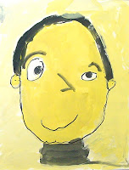
Pablo Picasso's Blue Period, in which he painted only blue paintings of sad subject matter, is a good example of how an artist used color to reflect his feelings. Ask children to think of the different feelings associated with colors before they choose the main color for their self portrait.
1. Students draw a simple self-portrait with pencil on a heavy piece of paper. It's a good time to review the basic proportions of the face (eyes in middle of oval, nose halfway down, etc.) They trace the pencil lines with a black Sharpie marker.
2. Students choose one main color - red, blue, green or yellow are good. Distribute this paint on a paper plate with a little black and white. Students can mix many variations of the main color by adding a little of each color together on the plates.
3. Students fill in each area of their drawing with a different color of paint. If some paint is watered down enough, they can paint over the black lines.
4. The entire face and background is painted and let dry. When complete, black lines may be traced again to make them stand out.
Labels: 1st grade, 2nd grade, 3rd grade, artist Picasso, paint
5 comments:

JUL 16, 2011

Tinted Self-Portrait
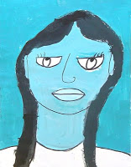
Pablo Picasso's Blue Period, in which he painted only blue paintings of sad subject matter, is a good example of how an artist used color to reflect his feelings. Ask children to think of the different feelings associated with colors before they choose the main color for their self-portrait.
1. Show the students how to draw a simple self-portrait in pencil on a heavy piece of paper. It's a good time to review the basic proportions of the face (eyes in middle of oval, nose halfway down, etc.) Have them trace the pencil lines with a black Sharpie marker.
2. The students choose one main paint color – red, blue, green or yellow are good – and distribute on a paper plate with a little black and white added to the side. (Acrylic and tempera paints will work for this.) Show the students how they can mix many variations of the main color by adding a little of white or black on the plate. The students are to fill in each area of their drawing with a different color of paint and let dry
3. Any black lines that were painted over may be traced again in marker to make them stand out.
Labels: 2nd grade, 3rd grade, 4th grade, 5th grade, artist Picasso, paint
4 comments:

MAY 23, 2010

How to Draw a Cubist Portrait
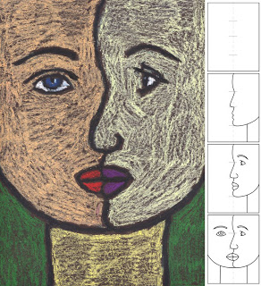Many 3rd graders in California learn that Picasso’s cubism was about seeing two sides of something at the same time. Here is a breakdown of steps that I use, which I hope are helpful.
1. Give each student a 9" x 12" piece of black construction paper. Have them fold the paper in half vertically so they have a middle line. Then they are to make a light pencil mark in the middle, and then in the middle of each of those sections as in Diagram 1.
2. A profile line is drawn down the middle, with the top of the nose hitting the top quarter mark, the bottom of the nose hitting the middle mark, and the bottom of the chin hitting the bottom quarter mark. The chin ends as a curve up and the neck line is added as in Diagram 2.
3. Profile features are added as shown in Diagram 3.
4. The face is completed with frontal view features. The chin and neck lines are added to symetrically match the right side as in Diagram 4.
5. After the pencil drawing is complete, the lines are traced with a black oil pastel, making the lines very fat. All the shapes are then filled in. Encourage the use of unusual colors.
Labels: 3rd grade, 4th grade, 5th grade, artist Picasso, drawing, oil pastel
13 comments:

FEB 25, 2010

Picasso Pastel Portraits
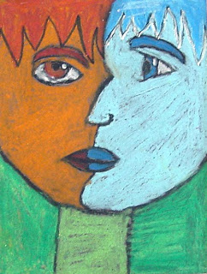Pablo Picasso was one of the most prolific artists ever, and one of his contributions wascubism, the idea of looking at something from different angles. A good way to demonstrate this idea is to draw a portrait with both a front and profile view.
1. With a 9" x 12" piece of black construction paper, show the students how to draw a profile down the middle of the paper. Start at the top center, draw a forehead straight down a couple of inches, then comes a nose that ends in the center of the paper, lips below, and chin that curves up and goes off the paper. Finally, add a neck to the bottom.
2. Complete the profile face with a profile eye, and chin line that matches the opposite side.
3. Complete the front view face with an eye that looks directly out, along with a mouth and chin.
4. Add hair and any other desired detail.
5. Trace the drawing with a black oil pastel. Press hard to make a dark line.
6. Fill in all of the drawing with oil pastels, leaving no paper to show. Encourage unusual colors, as many abstract artists do.
Labels: 4th grade, 5th grade, artist Picasso, oil pastel
9 comments:

Renoir

Draw like Renoir
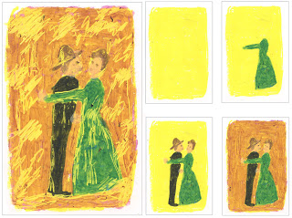
Auguste Renoir, a French Impressionist painter, was famous for his use of vibrant light and saturated color. This scratch art project is one way to play simulate that look of bright light on a sunny day.
1. I used the 24 pack of Portfolio brand oil pastels as they provide the soft covering needed for scratching away layers of color. Begin by covering your paper with a layer of yellow pastel.
2. This project is meant to simulate the look of THIS Renoir painting, so a simple side view of a dancing woman with her arm extended is drawn next in pastel as shown.
3. An old fashioned man is added next, still in pastel and colored heavily and filled in with more pastel.
4. The area around the couple is filled in with another pastel color.
5. A wooden stylus is used to scratch away areas that might reflect light on a sunny day. Details on the dress, the man's hat and more are all possibilities.
Labels: 4th grade, 5th grade, artist Renoir, oil pastel

Ringgold

Faith Ringgold Flag Story Quilt
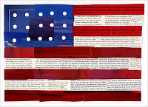Faith Ringgold, an African-American artist, is best known for her large story quilts. In 1985 she made a piece titled “Flag Story Quilt”which inspired this collage.
1. To help cut swatches, I gave the students this template to follow, printed on 8.5" x 11" cardstock. I passed out several old magazines to have them cut out swatches of red, and black and white type to fill in the stripes and blue swatches to fill in the rectangle. The pieces were attached with glue stick.
2. Students covered the blue rectangle with glue stick and arranged the hole punch circles for stars, as shown.
Labels: 4th grade, 5th grade, artist Ringgold, Black History Month, collage

Rothko

Miniature Rothko Painting
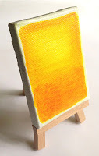
Mark Rothko (1903-1970) was an Russian-American painter who had quite a turbulent life and career. His rich use of oil colors were what he came to be most known for. I found that brush Sharpie markers on canvas can give almost the same effect as oil paints. Click HERE to see one of Rothko’s paintings.

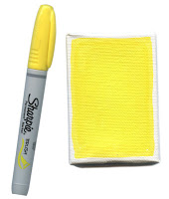
1. Color the background of the square with a yellow Sharpie Brush marker.

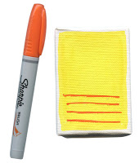
2. Add lines with an orange Sharpie Brush marker.

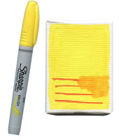
3. Use the yellow marker to smear the colors together.

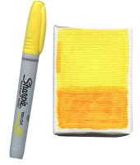
4. Use the yellow marker to smear more orange around the top.

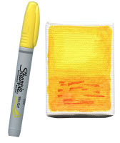
5. If more color is needed, add spots of orange and mix together with the yellow marker. Cover the painting with Mod Podge or clear gloss to add a shine.

Labels: 3rd grade, 4th grade, 5th grade, artist Rothko, Cre8time projects,markers
1 comment:

MAY 13, 2011

Mark Rothko Abstract Art
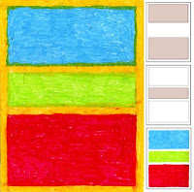
Mark Rothko emerged during the 1940s to create a new form of abstract painting. My goal was to have students think about the visual “weight” of colors.
1. I gave students lots of cardboard rectangles that were all 11" wide, and varying heights. On a 9" x 12" sheet of paper, they were to draw in pencil three separate rectangles that were of different widths – a large, medium and small.
2. The students choose 3 oil pastels, specifically ones that were very different from each other. All colors have a different visual weight to them, generally darker colors are heavy and brighter colors are light. The students filled the lightest weight color in the smallest rectangle, the medium in medium size and the heaviest in the largest rectangle. If they have trouble deciding, encourage them to just make their best guess. The point is for them to start thinking of colors from a new angle, not to be worried about right or wrong answers.
3. Lastly, a fourth color is chosen and colored in all around the rectangles, overlapping on the edges to get a painterly look. Heavy coloring, as always, looks best.
Labels: 4th grade, 5th grade, artist Rothko, oil pastel

Rousseau

Pastel Tigers

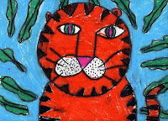
Henri Rousseau was a French artist that lived in the late 1800s. He tried to paint in the schooled manner of the traditional artists, but the innocence and charm of his work eventually won admiration of many avant-garde artists.
1. Students trace a 6" circle in the center of a 9" x 12" sheet of paper.
3. Draw a simple tiger face, starting with two eyes, two lines going down the center, a upside down triangle nose and two circles drawn to the sides. Whiskers are added, then ears, body and tail. Lastly, triangles may be drawn all around the edges for a tiger look.
4. Daw lots of leaves, some that are in the back of the tiger and some are in front. This will make the tiger look like he is hiding in the leaves.
5. Trace all the lines with a black marker and then color everything in with oil pastels.
Labels: 2nd grade, 3rd grade, 4th grade, 5th grade, artist Rousseau, oil pastel

Stella

Frank Stella Abstract Drawing
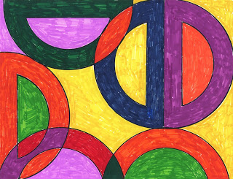Frank Stella is an American painter and printmaker who has fully embraced the idea that sometimes a painting can just be a flat surface, with no intention of having any depth to it. In the 1960s he created some paintings titled the “Protractor Series” which you can see HERE. For young students practicing geometric drawing, a protractor is the perfect tool to work with.
I like working with coated paper and Sharpie markers, so that is how I created this artwork. The pointy tips on the markers take some patience to color solid areas, so if I had young students (1st through 3rd grade) I would use some blunt tip markers and drawing paper. I’ve also found that limiting the amount of markers students may use (6 or 7?) forces repetition, which can create a kind of color rhythm in their art.
1. Every student will need a protractor and Sharpie, and should make overlapping shapes all over their paper. I would limit them to 6 or so protractor tracings, and that they all need to be either horizontal or vertical. Stella’s art is not freeform or random looking. It’s very clean and orderly and geometric, so that is the look the students should have as a goal.
Labels: 1st grade, 2nd grade, 3rd grade, 4th grade, 5th grade, artist Stella,markers

Thiebaud

“Sweet” Mother’s Day Card
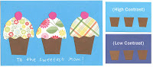
Cindy Littlefield posted this great cupcake card here first, but I needed to simplify it so it could be made in one class session. I also plan talk about contrast with students, so the background paper they choose has the most impact for their cupcake art.
1. I found all my paper supplies at Joann Fabrics. If you wait for sales, you can get some nice scrapbook paper without spending a ton of money. Students will start with three small rectangles of brown paper that they cut into identical cupcake bottoms.
2. Keeping the lesson about contrast in mind, they choose a background paper and fold it in half to make a card. The bottoms are centered and glued down.
3. Working with an array of scrapbook paper, they choose three swatches that look nice together. A top is cut from one, then traced and cut for the other two so all three look the same. All are glued down.
4. Small cherry circles are cut and glued on top of each.
5. A pencil crayon, crayon or gel pen may be used to write a message. I used my white Sharpie Poster paint marker.
Labels: artist Thiebaud, collage, mother’s day
No comments:

JUN 24, 2011

Wayne Thiebaud Ice Cream Cones
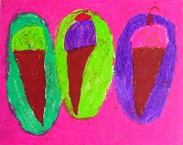Wayne Theibaud is famous for his paintings of cafeteria-style food. His art often spoke to the repetition of pies and cakes, so having students create multiple ice cream cones is a fun way to play with that idea.
1. Give the students a 9" x 12" paper, and with a horizontal layout, show them how to draw in pencil one simple cone in the center, and then another on either side.
2. Have each student trace all pencil lines with a thin black marker.
3. Distribute oil pastels to color all the cones and background. The thicker and brighter the better!

Labels: 1st grade, 2nd grade, 3rd grade, artist Thiebaud, oil pastel
3 comments:

FEB 2, 2011

Wayne Thiebaud Cupcakes
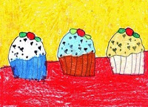Wayne Theibaud is famous for his paintings of cafeteria style food. He used lots of repetition, so having students create multiple cupcakes was a good way to imitate his style.
1. I gave each student a 3.5" square piece of paper and pencil and had them draw a simple cupcake. Then I gave them a 3.5" square of carbon paper and showed them how to trace and make a copy. If they traced their first drawing onto the middle of a 9" x 12" paper, and then one on the left and one on the right, the drawing had a good chance of being balanced.
2. A table line was added, all the lines were traced with a black marker.
3. The cupcakes were colored in with any colors the students chose.
Labels: 2nd grade, 3rd grade, 4th grade, artist Thiebaud

Van Gogh

Starry Night Collage
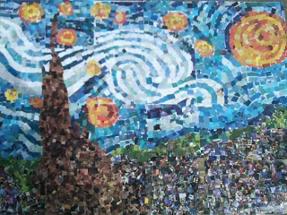
This amazing artwork comes for Linsay in Eugene, Oregon. She shared how her students (age 5-11) in the River Road Park and Recreation ASAP Program use donated magazine pictures, cut them into stamp sizes and glued them where they needed to go on my Starry Night template. Amazing! I never would have thought of such a creative use of one of my murals. Thanks so much for the inspiration Linsay!
Labels: 3rd grade, 4th grade, 5th grade, artist Van Gogh, recycle
3 comments:

MAR 3, 2012

Van Gogh Ceramic Landscape
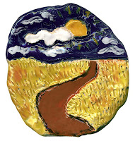
Van Gogh was known for his thickly painted landscapes, so you can replicate the look with clay and kiln and glazes.
1. Give each student about a baseball-size piece of clay, and have them form a smooth ball. Show them how to press the ball into a thick pancake, using a roller if possible.
2. Give each student a stick or stylus, and have them etch a drawing into the clay. It's good to start with a horizon line, and then add a road, grass and sky.
3. Fire the clay plates, glaze paint, and fire again. Vibrant Van Gogh-ish colors are essential!
Labels: 3rd grade, 4th grade, 5th grade, artist Van Gogh, ceramics
7 comments:

SEP 27, 2011

Sunflowers, Up Close & Personal
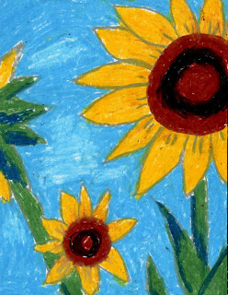Vincent Van Gogh is probably most famous for sunflower paintings. This project shows how pictures can become more interesting when some shapes break the frame and appear to go off the paper.
1. After viewing Van Gogh’s sunflower print from 1888, give the students an extra large paper, (I used 10" x 13") and an old CD to use as a template. They trace the CD somewhere on the paper – left, top, or right side, extended a bit off the page. Consideration should be given to balancing flowers. For instance, a large one is on the right, then a couple of smaller ones should be added to the left to create a visual balance.
2. Students may add their own radiating flower petals, stems and leaves. When the pencil drawing is complete, all lines are traced with a gray oil pastel (I used the Portfolio® brand). The flowers and sky are colored in. Heavy coloring will imitate the dense look of Van Gogh’s paintings.
CA National Arts Standard: Grade Six
Analyze Art Elements and Principles of Design

1.4 Describe how balance is effectively used in a work of art (e.g., symmetrical, asymmetrical, radial).
Labels: 4th grade, 5th grade, artist Van Gogh, oil pastel
1 comment:

FEB 16, 2011

Van Gogh Starry Night
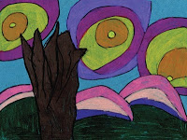
I like having students make their own simplified version of famous paintings, which can encourage their appreciation of the original.
1. View Van Gogh’s “Starry Night”, and discuss the composition; the foreground tree, the middle ground hills, and the background stars.
2. On a 12" x 9" turquoise paper, have the students draw their own simple tree or bush, just to the left of the center. Behind the tree are several simple hills. In the sky are at least 3 small circular stars. The students are to make the stars and hills "grow" with a series of larger circles and curves. Encourage them to make just a few of each with lots of space in between.
3. The pencil lines are traced with a thin black marker.
4. Lastly, good colored pencils are used to color all the shapes in.

Labels: 2nd grade, 3rd grade, artist Van Gogh, pencil crayon
1 comment:

SEP 1, 2010

Van Gogh Pastel Sunflowers
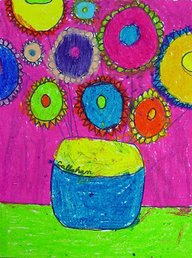This is a tribute to Van Gogh’s famous “Sunflowers” painting.
1. Instruct the students to draw a line for the table, and then the outline of a jar above it. Show them the jar in the original painting so they can add a curved middle line for dimension, and sign their name, in the style of Van Gogh.
2. Ask them to draw a series of circles for flowers, some large, some small, maybe some even going off the page. Add small petals around the flowers.
3. Connect the flowers to the jar by drawing stems, and add leaves.
4. Trace all the pencil lines with a medium size black marker.
5. Have the students fill in the shapes with good oil pastels. Show them that if they color everything very solidly, their picture will look much like an oil painting.
Labels: 3rd grade, 4th grade, artist Van Gogh, oil pastel
11 comments:

MAR 5, 2010

Starry City Night
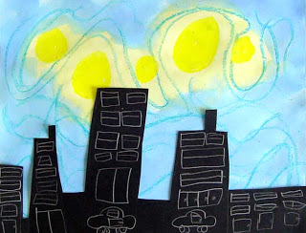Vincent Van Gogh's “Starry Night” painting has inspired many an art project, and this is just one more.
1. Distribute 9" x 12" watercolor paper, and ask students to make several large yellow oil pastel circles of various sizes in the top half. Next they are to draw with a blue oil pastel lots of curvy lines that go around all the yellow circles.
2. Give the students blue liquid watercolor paint and have them “wash” the entire paper with the blue paint.
3. Each student is to take a 6" x 12" sheet of black paper, and with a white oil pastel, draw a sky line that stairsteps up and down to make a building silhouette. (Make sure that the skyline is drawn horizontally and not vertically to match the watercolor paper.) Lots of details should be added, like windows and doors.
4. Lastly, the black silhouette should be cut out and glued to the sky background.
Labels: 2nd grade, 3rd grade, artist Van Gogh, oil pastel, paint
5 comments:

MAY 30, 2006

Starry Night Mural Diagram
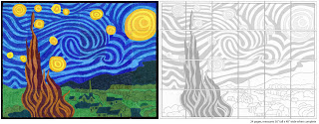

Warhol

Warhol Hand Prints
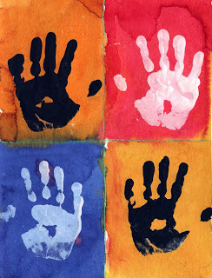I’ve started a new afterschool print class, and this Warhol hand print turned out pretty well, for even my young kinders. The watercolor background (quick drying time) allowed for the project to be done in one class.
1. I had pre-drawn the grid on the 11" x 15" watercolor paper, but the students had to trace it heavily with a dark crayon. Afterwards, they painted each rectangle a different color. I had them use my liquid watercolors in spill-proof cups to speed up the process.
2. The watercolor sheets were taken away to dry and the students practiced making leaf prints with white acrylic paint on black paper. It was quite messy, as I knew it would be, but they did all have a lot of fun.
3. After about 20 minutes of leaf printing, I set up a station with one plate of black acrylic paint and one with white. I wiped any excess paint off the hands, and the students made hand prints on the watercolor paper. The hands were flipped for the bottom row to make a checker pattern.
Labels: 0 grade, 1st grade, 2nd grade, 3rd grade, 4th grade, 5th grade, artist Andy Warhol, printmaking
1 comment:

JUL 23, 2010

Andy Warhol Soup Cans
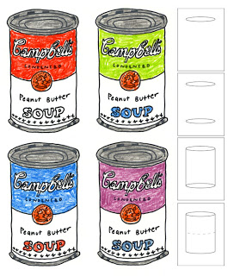Andy Warhol’sCampbell’s Soup Can painting has come to symbolize the pop art movement.
WEEK 1: Give the students a 9" x 12" sheet of paper, along with a 5" wide oval template that is the shape of the top of a can (in perspective). Show them how to trace one oval at near the top of the paper, slide the oval down about 7" and trace again. Connect the outside edges, erase the curve that will not show, and add the same curve to the middle of the can. After this, it is helpful for them to look at a Campbell's label to add details in their own style. I encouraged students to make up their own “flavor” and to cover all their pencil lines with a thin black marker.
WEEK 2: Prep work is needed here. Each student’s art needs to be xeroxed down 50%, and then duplicated 4 times. The students will then take all 4 copies of their original art, paste them down in a grid, and colored them in with colored pencils.
Labels: 4th grade, 5th grade, artist Andy Warhol, pencil crayon
7 comments:

JUN 10, 2010

Warhol Cat Drawing
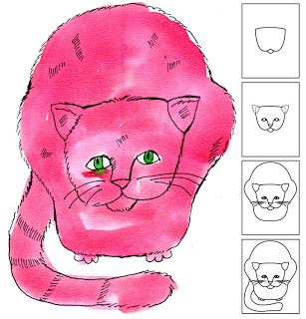Here's a little different take on a cat drawing, one where you can focus on drawing the face, and then kind of generalize a sitting position for the body. It's actually an attempt to copy Andy Warhol's famous "Red Sam"which is a very cool painting by a very cool artist.
1. Start by drawing a large, rounded "W" in the middle of the paper, and connect the tops points together to close in the head. Add a small curve at the bottom to make a chin.
2. Add two ears that sit at angles at the top and erase the inside lines. Draw two eyes and a nose that extends down to an upside down triangle.
3. Complete the face by drawing whiskers from the cheeks. Draw the cat body around the head by adding a large curve at the top and two bumps at the sides for the hips.
4. Add feet at the bottom and a long tail wherever there is room. After the pencil drawing is complete, trace the lines with a black Sharpie marker, taking care to make the lines fuzzy and broken like fur. Distribute watercolor paint and have fun filling in your beautiful cat!
Labels: 3rd grade, 4th grade, 5th grade, artist Andy Warhol, drawing,watercolor
5 comments:

MAR 10, 2010

Andy Warhol Portraits
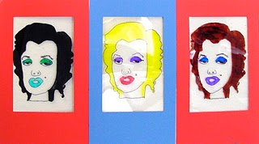Andy Warhol's repetitive style is fun to duplicate and the perfect example for students to create their own repetitive drawings using Sharpies on acetate.
1. Review some of Andy Warhol's portraits of Marilyn Monroe, Elvis Presley, etc. Collect several photos of celebrities or of the student's themselves and copy in black and white. Let the student's choose one photo, and give them 3 sheets of acetate and a black Sharpie marker.
2. Ask the students place the acetate over their photos and trace the edges in black. When tracing is complete, the voids can be filled in with colored Sharpies. After one drawing is complete, the students are to make two more, using a variety of colors.
3. Trim the acetate if necessary. Using colorful card stock, cut three paper frames to fit the size of the art. Tape the acetate to the back of each frame. The panels can be posted flat to a wall, or taped together to make a z-fold card.
This sample was made by a 2nd grader.
Labels: 1st grade, 2nd grade, 3rd grade, artist Andy Warhol, markers

Wood

American Gothic Face-in-the-Hole
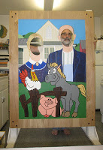
Grant Wood, Artist
A reader sent me this great photo a few days ago and wrote:
“I am sending you these photos to show you how I adapted your American Gothic mural to make a Face-in-the-Hole board for our school’s annual Harvest Hoedown. I have always been afraid of painting projects, but I loved doing this and am very happy with the results. My husband and I got to study the painting in a way that we never would have in a museum. I look forward to new additions to your store and may even attempt to paint another!
– Sincerely, Donna B.”

Wegman

William Wegman Trading Cards
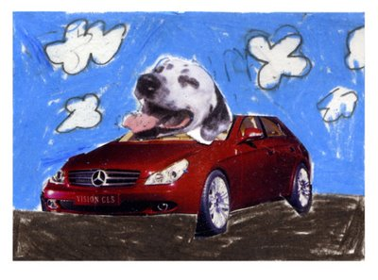William Wegman is a contemporary artist that has illustrated many children’s books and been a part of many videos on "Sesame Street".
1. I started my lesson by talking about how Mr. Wegman makes his dogs look human in his artwork. Distribute color prints of different dog heads that are about 3/4" square. I found some online and printed them with my color printer, but you could scan magazines photos, scale them down and print them out.
2. Instruct the students to cut out a dog head and an additional magazine item like a body or background. Both items should be glued down on a 2.5" x 3.5" card and colored with pencil crayons.
3. A second 3.5" x 2.5" size card should be filled out with their name, and the two can slide back-to-back into a trading card sleeve. You can buy these sleeves for 1¢ at most trading card venues.
Labels: 4th grade, 5th grade, art trading cards, artist W. Wegman, collage
2 comments:

MAR 16, 2011

William Wegman Art by Students
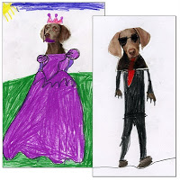
As a follow-up to my William Wegman posting a few days ago, here is the perfect example of why I think kid’s art is so great. My sample drawing was OK, but it had nowhere near the personality that these two drawings have. Thanks so much to Ani (left) and Chloe (right), two 2nd graders who let me share their adorable drawings. Honestly, when was the last time you thought of putting matching lipstick on a dog so he would coordinate with his dress? Or draw a bright red tie and sunglasses to make a super secret agent dog? I rest my case.
Labels: 0 grade, 1st grade, 2nd grade, 3rd grade, 4th grade, 5th grade, artist W. Wegman
1 comment:

MAR 14, 2011

William Wegman Drawings
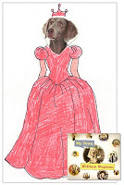
William Wegman is a photographer famous for his compositions with his Weimaraner dogs. His fascination with humanizing his animals has created hundreds of amazing videos and photographs. I like his book shown here as it shows the dogs in many everyday poses.
1. I created a composite of Weimaraner head photos that you can print HERE. I printed them in color and gave each student a strip that contained 4 different heads. They cut out and glued down their favorite on a 5.5" x 8.5" sheet of paper.
2. They then added a human body of their choice. Some older students were challenged to include an action pose.
3. When complete, the drawings were traced with a thin black marker and filled in with colored pencils.
Labels: 0 grade, 1st grade, 2nd grade, 3rd grade, 4th grade, 5th grade, artist W. Wegman

