Goals & Strategies for Coherence for Deep Learning
Blooms Taxonomy Levels | Art Based Skill/Strategy, GLAD  Tableau and Martha Game  Second Grade  Artful Learning Unit  Interdependence  (Objective- create a group Tableau demonstrating understanding of the interdependent relationship of economic buyers and sellers in a community. )
Creating | Students revise thinking and previous actions to repeat Tableau/M  Students can construct and justify a new point of view  GLAD Coop. strip paragraph to prove arguments analyzed
Evaluating | Students make connections with their choices in the tableau and draw conclusions.  (4 C’s rubric)
Analyzing | Audience members develop logical arguments to identify different parts of the Tableau/Martha by citing evidence and differentiating characters  Participating students explain concepts, and choices
Applying | Students make inferences with their role in a character tableau  Students compare/contrast characters and information on a Venn diagram  Students organize their understanding of the text/story and construct a dramatic skit  Martha Game – setting justification (urban, suburban, rural)
Understanding | Students show understanding of text information elements through their role in a simple Tableau / Martha  Students justify their role in the Tableau by showing evidence from the text  Students distinguish between their character roles
Remembering | Students access Social Studies newspapers on economic Producers and Consumers by teacher read aloud and/or independent reading, recalling who, what, where, when, why  - Identify story elements (character, setting, problem, or main points of non fiction information)  - Recall story elements naming, citing, quoting information from the text  - Think/Pair/Share  - Define/describe story elements through writing organization first, next, then, last and summarizing and Lori O Fab 4

Critical Thinking Strategies
- Turn & Talk
- Venn Diagram Organizer
- Three Step Interview
- 3 – 2 – 1
- Quick Write
- What? So What? Now What?
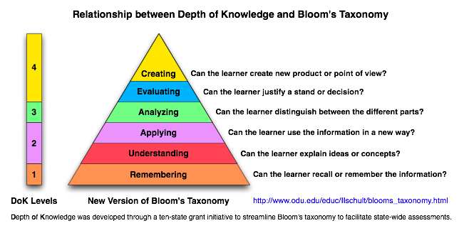
Goals & Strategies for Coherence for Deep Learning

- List an Art Based Skill/Strategy or GLAD Strategy that you currently enjoy using with your students.
- Locate the Bloom’s Taxonomy Level in which you think the strategy is taught. Describe the evidence that led you to this conclusion.
- Now, teach the strategy while applying one of the Critical Thinking Strategies listed below.
- Reassess. At what level of Bloom’s Taxonomy was the strategy taught. Why?
