Goals & Strategies for Coherence for Deep Learning
Blooms Taxonomy Levels | Art Based Skill/Strategy or GLAD Strategy  GRADE: 4  ABSS/GLAD Strategy: Integrating Tableau (Artful Learning Arts Based Skill and Strategy) and GLAD Strategies into our Language Arts Curriculum and Artful Learning Unit of Study  Unit Concept: Systems  Learning Objective (quick summary): Students create a Tableau Performance based on the GLAD strategies that they have used to access and explore the text in their “Treasures” Language Arts Curriculum. This series of strategies has been used with several different texts. Students need to take into account our four “Tableau Objectives” during the creation of their performances.
Creating | - In Small Groups, students create “Farmer in the Dell” sentence strips using the “Sentence Patterning Chart”  - Using their “Farmer in the Dell” sentence strips, the students create the scenery (using the Prepositional Phrase), characters (using the Noun and Adjectives), and Plot of their Tableau Performance. They also portray each of those elements by having each of their parts say something about what is happening in the scene.
Evaluating | • Tableau Performances have to include the following four specific objectives: 1) All performers face the audience, 2) Performers are at different levels, 3) Performers speak loudly and clearly, and 4) Performers include the content in their performance (in this case, the information from their “Farmer and the Dell” phrase created by the group using the “Sentence Patterning Chart”
Analyzing | - Venn Diagram Comparing and Contrasting Content (in this case, students compared and contrasted the communication systems that are used by ants and humans)  - Students use Tableau Performance Objectives to evaluate their Performance. This can either be done using a typed up rubric of the Tableau Performance Objectives or as a Peer Review with audience members indicating the objective that they saw during the performance.
Applying | - Student use knowledge gained from “Sentence Patterning Chart,” “Narrative Input Chart,” “Venn Diagram,” etc. to create their own “Farmer in the Dell” Sentences in small groups. “Farmer in the Dell” sentences are then used to create their Tableau performances while referring to the Tableau Performance Objectives.
Understanding | - Students can indicate how the Tableau Performance Objectives have been incorporated into their own performance as well as how other groups have included them in their performances.  - Students can indicate the specific content that their peers are trying to portray in their Tableau Performances.
Remembering | • Students can use their knowledge of the “Sentence Patterning Chart” and “Tableau” performances to create multiple-paragraph pieces of writing that include characterization, scenery, plots, and etc.

Critical Thinking Strategies
- Turn & Talk
- Venn Diagram Organizer
- Three Step Interview
- 3 – 2 – 1
- Quick Write
- What? So What? Now What?
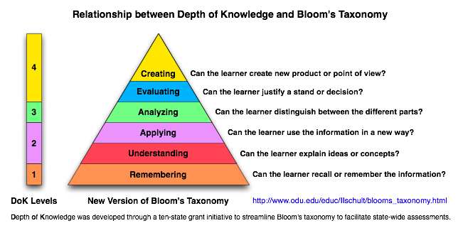
Goals & Strategies for Coherence for Deep Learning

- List an Art Based Skill/Strategy or GLAD Strategy that you currently enjoy using with your students.
- Locate the Bloom’s Taxonomy Level in which you think the strategy is taught. Describe the evidence that led you to this conclusion.
- Now, teach the strategy while applying one of the Critical Thinking Strategies listed below.
- Reassess. At what level of Bloom’s Taxonomy was the strategy taught. Why?
