Goals & Strategies for Coherence for Deep Learning
Blooms Taxonomy Levels | Art Based Skill/Strategy or GLAD Strategy  GRADE: 5  ABSS/GLAD Strategy: Tableau Artful Learning into reading…  Unit Concept: Interdependence  Learning Objective (quick summary) : Students create 3 part tableau exemplifying deep understanding of character analysis, author perspective, fresh point of view and unit concept using A Wrinkle in Time.
Creating | - Create rough draft of scene 1 (flip video playback and revise)  - Large thought bubbles/dialogue boxes for character emotion and action(had to revise using Learning HQ Action Verbs and Literary Themes- an essential adjustment)  - Class Cooperative Strip paragraph: Wrinkle in Time develops interdependence through….(not completed)
Evaluating | - Adapted What? So What? Now What? Used responses and arguments to 3 step interview to develop character perspective/analysis for Tableau then formulate a key question from character to author regarding circumstance or traits given or taken from character  - Team task: Sketch n design scenes, transition signals,  - Review Tableau Rubric with You Tube video examples  - Suspending Your Disbelief: Learning objectives  Understand the differences between science fiction and realistic fiction.  Recognize ways in which science fiction incorporates elements of the realistic and the imaginary.
Analyzing | - Venn Diagram with Meg/Charles Wallace, debate shared characteristics and habits,  - Ozskus Read Like a Writer Fiction Mark(loved this!!!!!)  - Three Step Interview: “If you were on Camazotz how would you have survived IT?” “Would you have chosen to leave C.W., defend your response”
Applying | - Ozskus FAB 4 Clarifier- close reading context clues for character development and unit theme,  - GLAD high lighting, clunkers/linkers,  - I SEE, I KNOW, I WONDER (every chapter)
Understanding | - GLAD Sentence Patterning Charts, Think/Pair/Share (10/2’s and Numbered Heads paired with Oczkus Mark the Spot Icons)
Remembering | Ozskus: FAB 4 summarizer, GLAD Character T-Graph (see/hear/feel), ABSS: Alteration Observation – then modified charades(character changes over time- facially, posture, stance/placement in group of characters), Character “Interviews” (questions designed from Ozskus Question Asker and GLAD character pictorial  Establish Rubric for Tableau, note taking and secure in AVID binder

Critical Thinking Strategies
- Turn & Talk
- Venn Diagram Organizer
- Three Step Interview
- 3 – 2 – 1
- Quick Write
- What? So What? Now What?
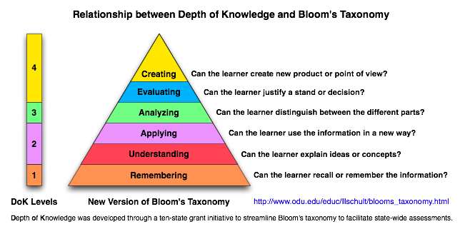
Goals & Strategies for Coherence for Deep Learning

- List an Art Based Skill/Strategy or GLAD Strategy that you currently enjoy using with your students.
- Locate the Bloom’s Taxonomy Level in which you think the strategy is taught. Describe the evidence that led you to this conclusion.
- Now, teach the strategy while applying one of the Critical Thinking Strategies listed below.
- Reassess. At what level of Bloom’s Taxonomy was the strategy taught. Why?
