Name

Four-Square

If were a plant he would be a because | If were an animal he would be a because
If were a geographic feature he would be a  because | If were a color he would be because

> Cause and Effect T-Chart

Cause Effect

Cause 1 Effect 1

Cause 2 Effect 2

Cause 3 Effect 3

Cause 4 Effect4

! Brother, Can You Spare a Dime?
sung by Bing Crosby
Dime

lyrics by Yip Harburg, music by Gorney Harburg (1931) sung by Rudy Vallee or Bing Crosby

They used to tell me I was building a dream, and so I followed the mob,

When there was earth to plow, or guns to bear, I was always there right on the job. They used to tell me I was building a dream, with peace and glory ahead,
Why should I be standing in line, just waiting for bread?

Once I built a railroad, I made it run, made it race against time.

Once I built a railroad; now it’s done. Brother, can you spare a dime? Once I built a tower, up to the sun, brick, and rivet, and lime;
Once I built a tower, now it’s done. Brother, can you spare a dime?

Once in khaki suits, gee we looked swell, Full of that Yankee Doodly Dum,
Half a million boots went slogging through Hell, And I was the kid with the drum!

Say, don’t you remember, they called me Al; it was Al all the time.

Why don’t you remember, I’m your pal? Buddy, can you spare a dime?

Once in khaki suits, gee we looked swell, Full of that Yankee Doodly Dum,
Half a million boots went slogging through Hell, And I was the kid with the drum!

Say, don’t you remember, they called me Al; it was Al all the time.

Say, don’t you remember, I’m your pal? Buddy, can you spare a dime?

! There’s a New Day Comin’
[RealAudio at: http://www.redhotjazz.com/tlband.html]

Ted Lewis and his Band

New day’s comin’,
As sure as you’re born! There’s a new day comin’, Start tootin’ your horn,
While the cobbler’s shoeing, The baker will bake,
When the brewer’s brewin’, We’ll all get a break!

Now, a new day’s comin’, For Levee and Burke, New day’s comin’,
For boss and for clerk, No more bummin’, We’ll all get to work,
There’s a new day coming soon!

! Sound Source Chart
spiders

Sound  Source | How is sound produced? | How do the sound waves travel? | Can you change the pitch (make it higher or  lower)? How? | Can you change the intensity (make it louder or softer)? How?
Rubber bands
on boxes
Slide whistle
Whirly tube
Fork and string
Drum,
rice
and pan

Inquiry Center 3: Sound Exploration

Name

! Sound Starburst

makes me laugh

excites me

makes me sad

A sound that...

calms me

makes me alert

makes me remember

A Fanfare for

by:

! The Making of the Fanfare for the Common Man

The composer Aaron Copland was invited to contribute a fanfare for brass and percussion to a project initiated by the conductor
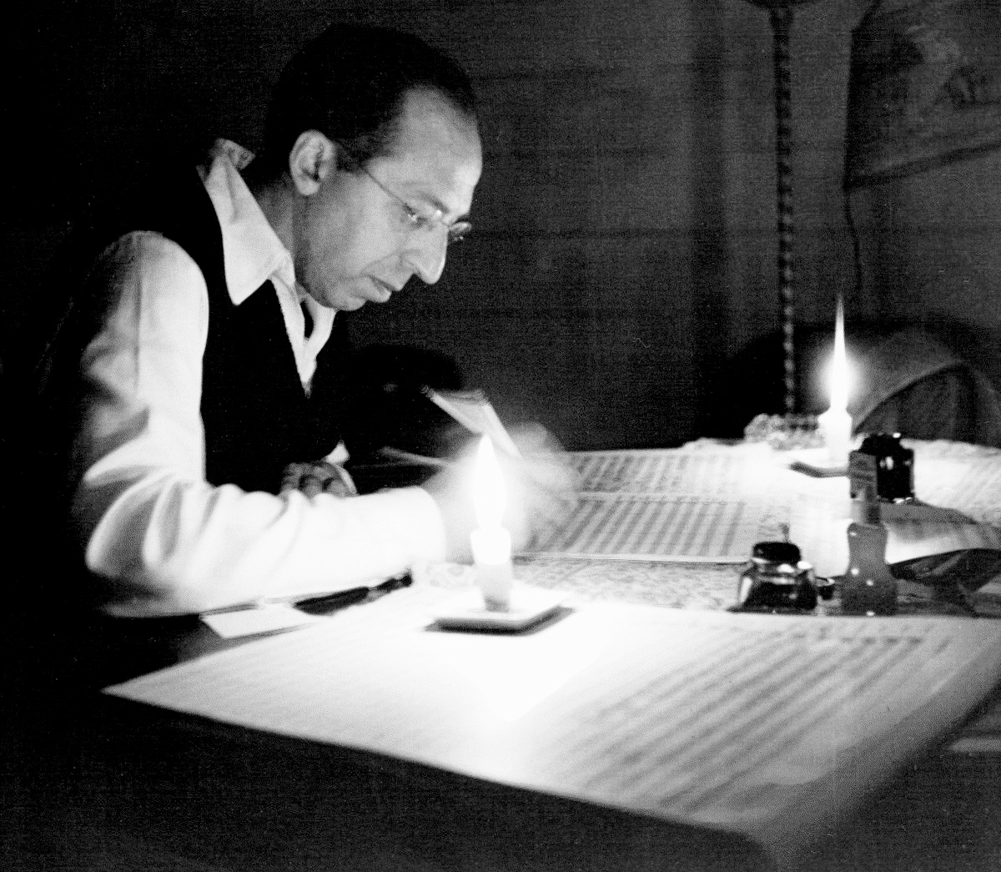Eugene Goossens and the

Cincinnati Symphony in

1942 as a morale-booster

in support of the war effort. The Symphony used this fanfare, and those written by other composers, as concert-openers during the coming season.

Copland wanted his fanfare to communicate his concern for the poor and downtrodden. He considered calling it Fanfare for the Four Freedoms in reference to President Roosevelt’s
1941 State of the Union address. Later on he wrote, “I sort of remember how I got the idea of writing A Fanfare for the Common Man – it was the common man, after all, who was doing all the dirty work in the war and the army. He deserved a fanfare.”

To Copland’s astonishment the Fanfare became his best- known and loved composition. Used by rock stars, jazz artists, politicians, movie scores, and the Olympics, to name but
a few, the Fanfare commands a moment of awe and pride whenever it is heard.

This explanation will need to be trimmed out and
placed inside an envelope.
Inquiry Center 4 : The Common Man as a Hero

Explanation: The YES cards portray common people as heroes. The NO cards are everyday people going about their business, not doing anything that is particularly heroic.

Group Brainstorm: Now that we’ve got you thinking about what a hero is or isn’t, brainstorm a list of attributes that describes an everyday hero with your group. Use markers and the 11” x 17” paper provided.

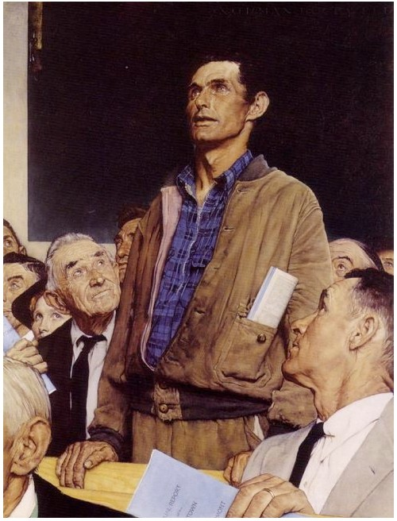Freedom of Speech
Norman Rockwell

FOR EOU::ATIONAL USE ONLY- NORI\.'\A,N RO:KWELL MUSEUM
1943

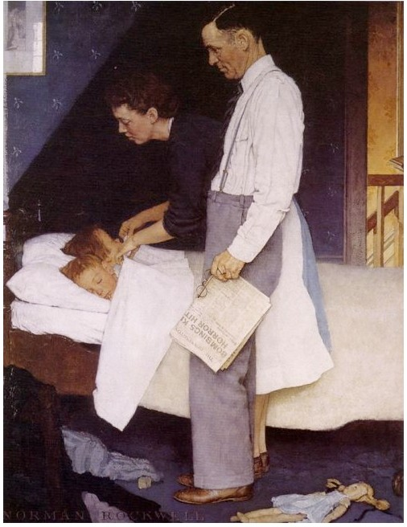

Freedom from Fear
Norman Rockwell
FOR EDUCATIONALUSEONLY- NORMAN ROCKWELLMUSEUM
1943

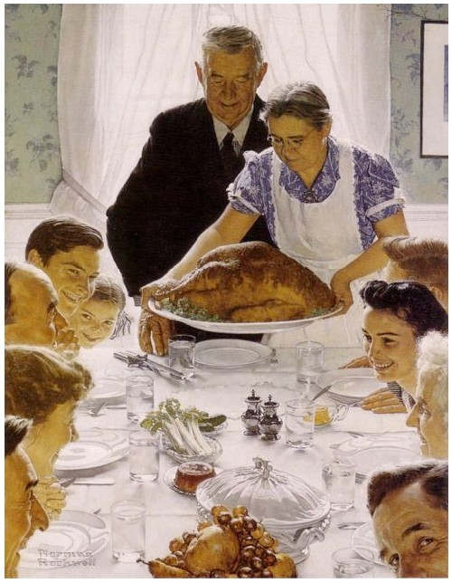

Freedom from Want
Norman Rockwell

FOR EOU::ATIONAL USE ONLY- NORI\.'\A,N RO:KWELL MUSEUM
1943

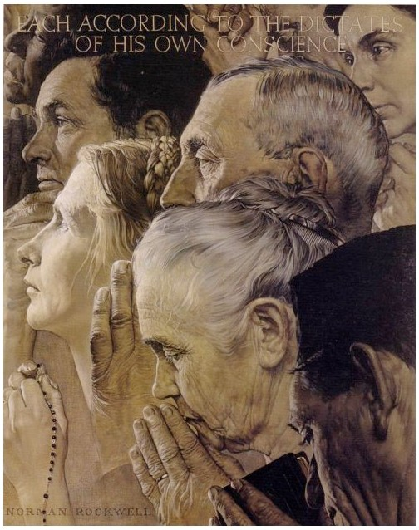

Freedom to Worship
1943

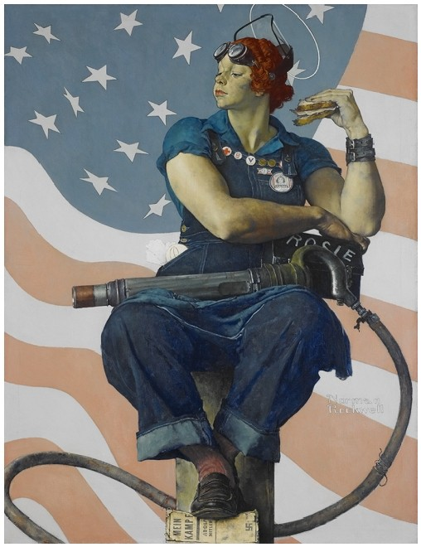

Rosie the Riveter
1943

Causes and Effects of the Great Depression

Causes:

Effect:
The Great Depression

Inquiry Center 2: The Great Depression

The Great Depression

12

10

8
"c:'
0

4

2

0

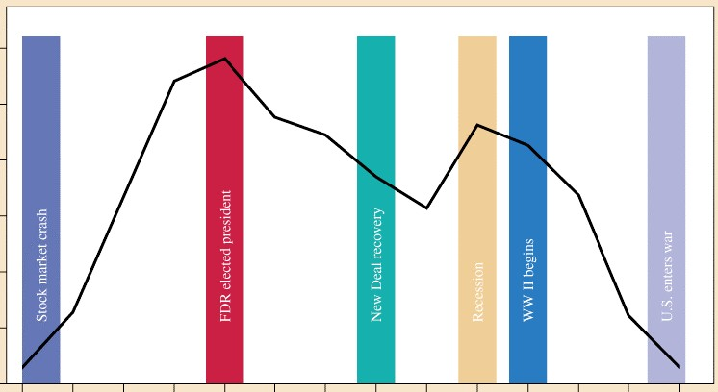
1929 1931 1933 1935 1 937 1939 1941

Figure 24.1 Unemployment, 1929-1942

The Great Depression

Bank Failures in the United States
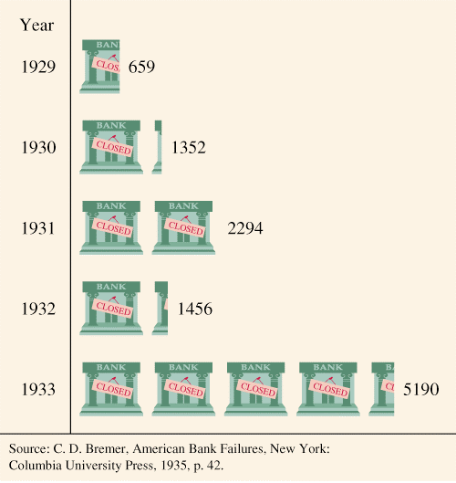1929-1933

The Four Freedoms
Franklin D. Roosevelt’s Address to Congress

In the future days, which we seek to make secure, we look forward to a world founded upon four essential human freedoms.

The first is freedom of speech and expression—everywhere in the world.

The second is freedom of every person to worship God in his own way—everywhere in the world.

The third is freedom from want—which, translated into universal terms, means economic understandings which will secure to every nation a healthy peacetime life for its inhabitants-everywhere in the world.

The fourth is freedom from fear—which, translated into world terms, means a world-wide reduction of armaments to such a point and in such a thorough fashion that no nation will be in a position to commit an act of physical aggression against any neighbor—anywhere in the world.

That is no vision of a distant millennium. It is a definite basis for a kind of world attainable in our own time and generation. That kind of world is the very antithesis of the so-called new order of tyranny which the dictators seek to create with the crash of a bomb.

—Franklin D. Roosevelt

JANUARY 6, 1941

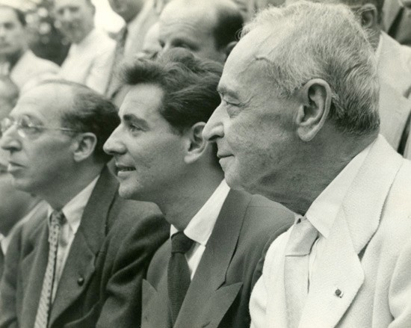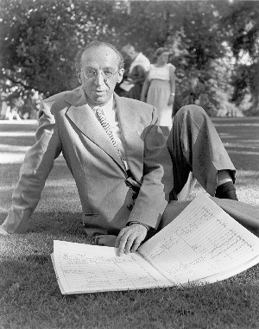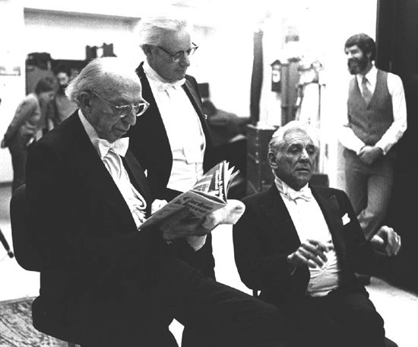

Aaron Copland, Leonard Bernstein and
Serge Koussevitsky, Tanglewood, 1949

Aaron Copland, Portrait, Tanglewood, 1949

Aaron Copland, Leonard Bernstein and Leo Smit, 1984

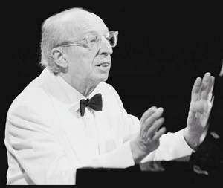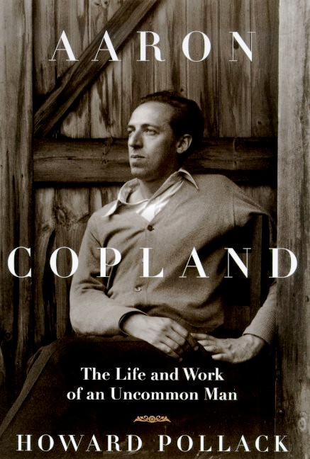

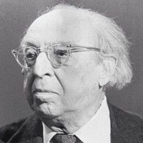Aaron Copland • Later Years

